

|  |
| --- |
|  |
| ANA REVISION  PROGRAMME 2014 |
| GRADE 4 |
|  |
| **LEARNER ACTIVITIES** |
|  |

|  |
| --- |
|  |

**ANNUAL NATIONAL ASSESSMENT 20ASSESSMENT GUIDELINES**

**MATHEMATICS**

**GRADE 4**

**INTRODUCTION**

The 2013 cycle of Annual National Assessment (ANA 2013) will be administered in all public and designated1 independent schools from 10 to 13 September 2013. During this period all learners in Grades 4-6 will write nationally set tests in Mathematics. The results will be used to report progress related to achieving the goals set in the *Action Plan 2014, Towards* *Schooling 2025*.

The ANA tests will be written during the third school term and, therefore, the Department of Basic Education (DBE) has developed Assessment Guideline documents for each grade and subject (Mathematics) outlining the minimum curriculum content that must be covered by all learners prior to the writing of the test. ***The Assessment Guidelines define the scope of work that will be covered in the test for each grade and subject.***

**INTERMEDIATE PHASE**

In Grades 4-6, the tests will cover work that is prescribed for the first three-quarters of the school year. The Assessment Guidelines are arranged in three columns: Content Area; Concepts and Skills; and Content to be assessed. It is important to note that the ANA 2013 Assessment Guidelines do not imply that the delimited scope is all that must be taught and learnt during the school year. Instead, the Assessment Guidelines provide the minimum curriculum requirements that must be covered by the end of the third school quarter.

Teachers are expected to use these Assessment Guidelines together with the other resources for their teaching and assessment programmes.

To support school-based assessments and also ensure that learners gain the necessary confidence to participate with success in external assessments, exemplar test questions were developed that teachers can use in Mathematics lessons. The exemplar test questions were developed based on the curriculum that covers terms 1, 2 and 3 of the school year. The exemplars, which include the ANA previous question papers, supplement the school-based assessment that learners must undergo on a continuous basis and does not replace the school based assessment. The exemplars are designed to illustrate different techniques or styles of assessing the same skills and/or knowledge. Exposure to a wide variety of questioning techniques or styles gives learners the necessary confidence to respond to different test items. By using the ANA exemplars as part of their teaching resources, teachers will help learners become familiar with different styles and techniques of assessing. With proper use, the exemplars should help learners acquire appropriate knowledge and develop relevant skills to learn effectively and perform better in subsequent ANA tests. It is important to ensure that learners eventually get sufficient practice in responding to full tests of the type of the ANA model test.

**How to use the exemplars**

While the exemplars for a grade and a learning area have been compiled into one comprehensive set, the learner does not have to respond to the whole set in one sitting. The teacher should select exemplar questions that are relevant to the planned lesson at any given time. Carefully selected individual exemplar test questions, or a manageable group of questions, can be used at different stages of the teaching and learning process as follows:

* At the beginning of a lesson as a diagnostic test to identify learner strengths and weaknesses.
* During the lesson as short formative tests to assess whether learners are developing the intended knowledge and skills as the lesson progresses and ensure that no learner is left behind.
* At the completion of a lesson or series of lessons as a summative test to assess if the learners have gained adequate understanding and can apply the knowledge and skills acquired in the completed lesson(s).
* At all stages to expose learners to different techniques of assessing or questioning.

**CONTENT AREA: WHOLE NUMBERS**

**COUNTING, ORDERING, COMPARING, REPRESENTING, PLACE VALUE AND ROUNDING OFF**

**Count forward and backwards in whole numbers between 0 and at least 10 000**

1. Fill in the missing numbers.

a. 3 050; 3 075; 3 100; _______; _______; _______.

b. 7 050; 7 000; 6 950; _______; _______; _______; 6 750.

c. 4100; 4125; 4150; 4175; _______; ________.

2. Write down the next 4 numbers in each sequence.

a. 930; 933; 936; ______; _______; _______; _________.

b. 4 884; 4 882; 4 880; _______; ______;_____;_____.

3. Complete the following sequences:

a. 4 102; 4104; 4 106; _________ ; ___________

b. 5 991; 5 989; 5 987; _________ ; __________

4.Fill in the missing numbers on the number line.



a.

b. 4.



5. Complete the following number chains.

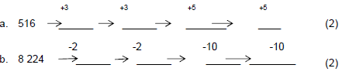

**Order, compare and represent numbers**

Arrange the following numbers from biggest to smallest:

e.g. 750, 75, 7500, 705

Answer: 75, 705, 750, 7500

1. Arrange the following numbers from biggest to smallest:

4010, 4001, 4100, 4040

__________________________________________

1. Write the following numbers in order from the smallest to the biggest:

4810, 8410, 4180, 8140

__________________________________________

3. What is the biggest number you can make using the digits below?

6 0 5 9

______________________

4. a. Which whole number comes just before 5 646? ____________

b. Which whole number comes directly after 6 789? ____________

5. Write 5 018 in words. ___________________________________

6. Use digits to write down each number.

a. four thousand, eight hundred and thirteen

_______________________________

b. six thousand and sixteen

_______________________________

7. Fill in > or < to compare the following numbers.

**E.g. 7005 * 7050**

**Answer: 7005 < 7050**

a. 7 964 _______ 7 946

b. 3 010 _______ 3 110

**Place value**

Write down the value of the underlined digit

**e.g. 7005**

**Answer: 0Tens**

1. Write down the value of the underlined digit.

**3** 503 _____________________

2. The value of the underlined digit in the number 4 **3**50 is

_____________________________

3. What is the value of the underlined digit in 5 **6**14?

_____________________________

4. Give the value of the underlined digit in 7 6**9**4. ______________

5. Write down the number represented in the diagram.

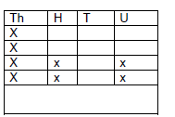

____________

6. Calculate the difference between the values of the underlined digits in:

2 **4**75 and 2 0**4**5 ____________________________

**Round Off to the nearest 10, 100 or 1000:**

**Round off the number below to the nearest 10**

**E.g. 7057**

**Answer: 7060**

1. Circle the correct answer:

a. The number 454 rounded off to the nearest 10 is ……

400; 450; 455; 460

2. Complete...

4 948 rounded off to the nearest 10 ≈ _____________.

4 948 rounded off to the nearest 100 ≈ _____________.

4 948 rounded off to the nearest 1000 ≈ _____________.

3. R 14, 76 ≈ _________ rounded off to the nearest rand.

R 4, 06 ≈ __________ rounded off to the nearest rand.

4. Mrs Patel bought sweets for R13, 99 and a packet of chips for R3, 14.

Calculate how much she spent correctly to the nearest rand.

________________________________

5. Is 1 758 closer to 1 700 or 1 800? ________________

6. Round off 676 to the nearest 100: __________________

**Number sentences to describe a problem:**

Complete the following number sentence:

**e.g. 720 = + 450**

**= 720 - 450**

**Answer: 270**

1. Complete the following number sentences:
2. 242 - = 21
3. ÷ 25 = 4
4. Fill in the missing number below:

a.

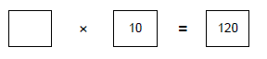

b.

1. Write down the number sentences for the following word problems:
2. Sammy has 23 marbles. Imran has 12 more marbles than Sammy. Together they have 58 marbles. _____________________________
3. David picked 112 cabbages. He packed 8 cabbages into each bag to send to the market. In total, he sent 14 bags to the market.

____________________________________________

1. Yusuf has R84, 00 to buy fancy chocolates for his friends. One fancy chocolate costs

R6, 00. How many chocolates can he buy?

_________________________________________

1. Create your own word problem using the number sentence : 35 × 9 = 315

_______________________________________________

1. Fill in **+** or **–** to make the following sentences correct.

a. 165 ______ 145 _____ 48 = 262

b. 789 ______ 709 ______207 = 287

1. Draw a circle around the letter of the correct answer.

Which numbers below mean the same as 5 x (6 + 2)?

a. (5 x 6) + 2

b. (5 x 2) + 6

c. (6 + 2) x 5

d. (5 + 2) x 6

7. Use the reciprocal relationship

**E.g. 12 X 3 = 36 36 ÷ 12 = 3 or 36 ÷ 3 = 12**



Complete the following:

1. 7 x 3 = 21 ________________



1. 30 ÷ 6 = ________________



1. 48 ÷ = 12 _______________



Say whether the following is TRUE or FALSE.

1. 54 + 29 equal to 29 + 54? _____________
2. 67 – 45 is equal to 45 – 67 _____________

8. 78 x 8 = 624 means 624 ÷ 8 = ______ and 624 ÷ 78 = _____

9. Use the given multiplication sentence to write 2 division sentences.

9 x 4 = 36 ______________ ________________

10 . Look at the number triangle below and write down 2 different number sentences.

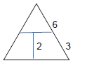

_________________

_________________

11. Granny used beads to make a necklace. For every 5 red beads, she used 2 yellow beads.

When the necklace was finished, it had 8 yellow beads. How many red beads were used?

________________________________________________

**Addition and Subtraction of whole numbers**

**e.g. 362 + 486**

**300 + 60 + 2 + 400 + 80 + 6**

**= 300 + 400 + 60 + 80 + 2 + 6**

**= 700 + 140 + 8**

**= 800 + 40 + 8**

**= 848**

**743 – 684**

**= 700 + 40 + 3 – 600 – 80 - 4**

**= 600 + 130 + 13 – 600 – 80 - 4 (Break up 743 into 600+130+13)**

**= 600 – 600 + 130 + 13 – 4**

**= 50 + 9**

**= 5**

**Use any method of your choice to calculate the following.**

1. 1 4 0 7 + 6 8 9

2. 8 3 2 6 - 7 6 8

1. 6 832 + 2 594

4. 3 648 – 555

5. 5 321 + 492

6. 3 468 – 545

7. Calculate:

a. 3 846 + 3 217

____________________

____________________

_________________

b. 2 752 + 4 356

____________________

____________________

_________________

8. Calculate 5 726 – 1 334.

____________________

____________________

9. Write down the missing number.

9 7 0

-______

1 3 9 6_

10. Calculate the difference between the values of the underlined digits in the numbers

**9** 008 and 8 10**9**.

____________________

____________________

_________________

**CONTENT AREA: PATTERNS, FUNCTIONS AND ALGEBRA**

**Numeric and geometric patterns**

1. Complete each number pattern below:

a. 1; 2; 4; 7; __________; _________; _____________

b. 1; 6; 11; ___________; _________; _____________

2. Sipho counts like this:

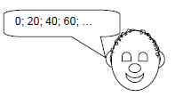

1. Will the number **560** be part of this pattern? _________________
2. How do you know this? _____________________________________

3. Study the pattern below:

1 = 1

1 + 3 = 4

1 + 3 + 5 = 9

1 + 3 + 5 + 7 = 16

Write down the next two lines of this pattern. ___________________________

**4. Fill in the missing numbers in the below diagram:**

**Example 1**

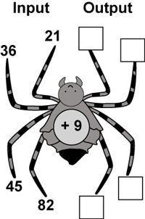

1. **21 + 9 = 30**
2. **36 + 9 = 45**
3. **45 + 9 = 54**
4. **82 + 9 = 91**

1.

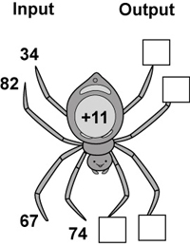

2.

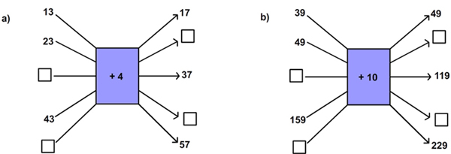

**Investigate and extend numeric and geometric patterns**

**E.g. ________________________**

1. Draw the next five shapes in this pattern:



--_____________________________________

2. How many matches are needed to make the 4th shape?



__________________

3. a. Complete the design on the wall below:

b. In which country can you find this design? _________________

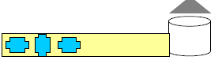

4. Draw a circle around the letter of the correct answer.

What is the 12th shape in this pattern?

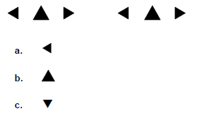

**Relationships or rules in words:**

1. One beetle has 6 legs



Two beetles have 12 legs



How many legs do 20 beetles have? ______________________

2. Identify the rule in each sequence.

a. 44; 49; 54; 59; ___________________________

b. 67; 77; 87; 97; ___________________________

c. 2; 6; 18; 54; _____________________________

3. A pattern is shown in the table. Explain it in words. __________________________________

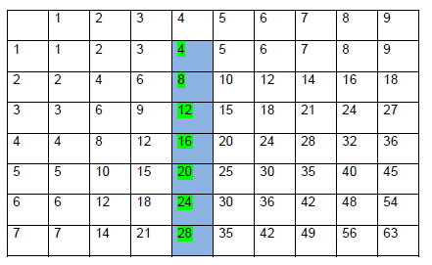

**Multiplication and Division of whole numbers:**

**e.g. 53 x 32**

**53**

**X 32**

**6 (2x3)**

**100 (2x50)**

**90 (3x30)**

**1500 (30x50)**

**1696**

1. Calculate the following:

56 x 24

_____________

_____________

_____________

_____________

2. What is the product of 37 and 45? ___________________________

___________________________

3. Write the repeated addition sum in shortened form.

5 + 5 + 5 + 5 + 5 + 5= _____ x 5 = ________

4. Use the break down method to calculate 46 x 32.

____________________

____________________

_________________

5. Use the vertical method to calculate 24 x 64.

____________________

____________________

_________________

6. Complete the sentence: 20 x 8 = ______ x 20

7. Tom wrote 12 sentences with 11 words in each, which means Tom wrote

___________ words altogether?

8. Complete...

If 9 x 8 = 72 then _________ x 9 =72

**Division of at least whole 3-digit by 1-digit numbers:**

**e.g. 969 3 =**



**3 2 3**

**3 9 6 9**

**= 323**

1. Divide the following

a. 135 ÷ 9 = ____________

b. 296 ÷ 8 = _____________

c. 722 ÷ 4 = _____________

2. Calculate the following:

(i) 7 217 = _________ (ii) 2 396 = __________

3. Fill in > , < or = to make a correct sentence.



500 ÷ 5 100 ÷ 10

4. Say whether the following is TRUE or FALSE.

a. 30 ÷ 5 is equal to 5 ÷ 30 _________________

5. Draw a line connecting the question in column A to the correct answer in column B.

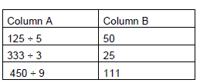

**Time:**

**Reads, tells and write analogue, digital and 24-hour time**

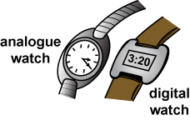

1. Write the time shown on the clock as a 24-hour time.

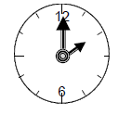

____________________

2. Look at the Departures board at the airport and answer the question which follows:

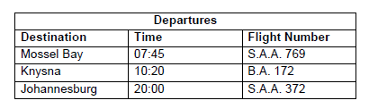

Draw an analogue clock face to show the time of departure of flight number S.A.A. 769

_____________________________________

3. Your school starts at 08:00 in the morning and ends at 13:30. How much time are you spending at school per day? ____________________________________

4. A man leaves Cape Town at 10.30 a.m. and arrives in George at 3.45p.m.How long did he take to

complete his journey? ___________________________________

5.1 Your class has won a trip to Gold Reef City. This is the timetable for the day:

|  |  |
| --- | --- |
| **8:30** Board the bus.  **9:00** Arrive at Gold Reef City.  **9:30** Get to ticket office window.  **10:00** First ride on “the water log”.  **10:30** Up the ski slope to slide down.  **11:00** Meet at shop for snack.  **11:30** Climb Captain Cook’s Ship to explore. | **12:00** Lunch time: hamburger and chips.  **12:45** Free time to wander around.  **1:35** Meet for class photos.  **2:00** Ghost town ride.  **3:00** Return to bus.  **3:30** Back to school. |

a) How much time did you get for lunch? __________

b) How long did you have to wait to buy your ticket? ________

c) How much time was allowed for the ghost town ride? ________

5.2 Write the following times as: **am** or **pm**

a)Dinner is at 18: 30 ______________

b) School finishes at 15: 15 ______________

c) Sunrise is at 6: 45 __________________

**Solve problems involving calculation and conversion between time units**

1. Complete the following:

a. A century = ____________ years.

b. 3 years = __________ months.

c. June has _________ days.

d. A decade = _________ months

2. Complete the table below:

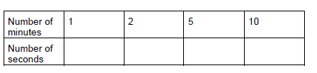

3. Mark’s birthday is on the 2nd of November. Jordan’s birthday is on the 20th of the same month.

They were both born in the same year at 08:00 in the morning.

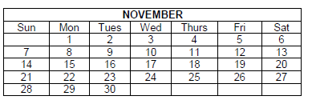

3.1Tick each boy’s date of birth on the calendar.

3.2 Who is the older boy? __________________

3.3How many days apart were they born? ___________________

4. John’s birthday is on the 17th of June. Mark’s birthday is on the 23rd of June. They were both born in the

same year at 8:00 in the morning.

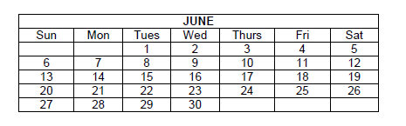

4.1. Tick   each boy’s date of birth on the calendar.



4.2. Who is the younger boy? __________________

4.3. How many hours apart were they born? _____________________________

**CONTENT AREA: DATA HANDLING**

**Organise and record data using tallies and tables**

1. Learners in a class choose their favourite fruit and vegetables.

Complete the tally table of what the learners like.

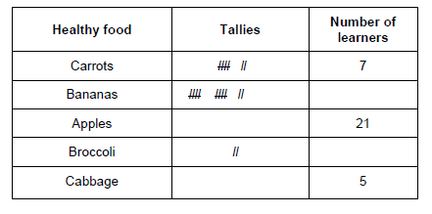

2. Mrs Patel keeps a record to show how many textbooks she gets.

Draw tally marks in the chart to show how many she got in February.

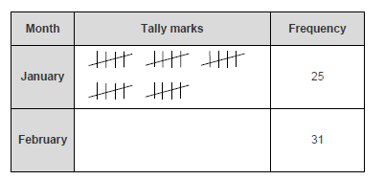

3. The graph shows the number of awards learners won in a Mathematics test.

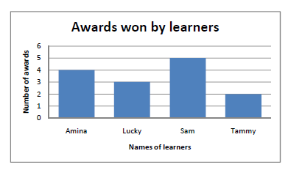

1. Complete the frequency table below using the data from the graph above:

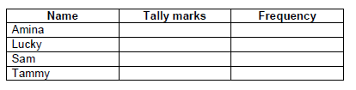

1. Who received the most awards? ____________________
2. How many awards were won altogether? __________________

**Read and interpret data presented in graphs**

1. A Farmer used a bar graph to record the number of kilograms of meat products from his ox.

Use the bar graph to answer the questions that follow.

***Meat products from the ox****.*

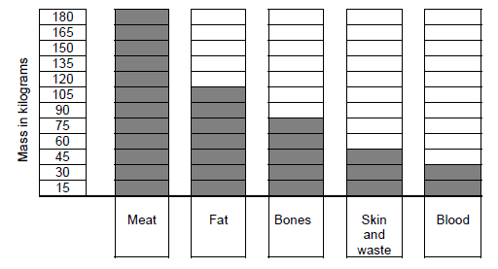

1.1 How many kilograms of meat were there? _______________________________

1.2 How many fewer kilograms of bones were there than of fat? _________________

1.3 How much skin, waste and blood were there in kilograms? __________________

1.4 What is the total mass, in kilograms, of all the meat products?

_________________________________________________________________

2. The clinic did a survey to find out which foods learners like best.

Answer the questions below.

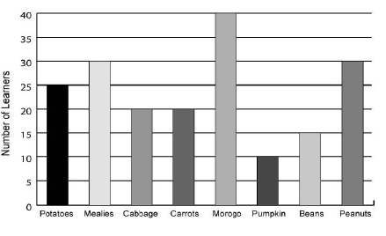

2.1 How many learners like mealies?

________________ Learners

2.2 Which food is liked just as much as mealies?

_____________________

2.3 Which food did they like the most?

_______________________

3. The bar graph shows the favourite cool drink flavours of Grade 4D learners.

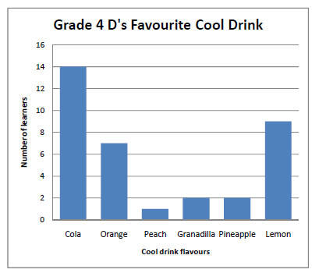

1. What is the difference between the numbers of learners who prefer the cola to the lemon flavour?

________________________________________

b. How many Grade 4D learners were questioned altogether?

________________________________________

4. The pictograph shows the popular toys amongst learners.

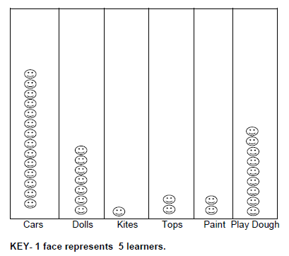

a. Which toy is the most popular? ____________________

b. Which toy is the least popular? ____________________

c. How many learners chose play dough? __________________

d. How many more learners prefer dolls to tops? _____________________

**Multiples of single –digit numbers to at least 100:**

1. Circle all the numbers in the triangle which are multiples of 3:

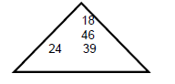

2. Will I count the number 46 when counting in multiples of 6 up to 100? _______________

3. Write down the first six multiples of 8. ______________________________________

4. Circle all the multiples of 7.

29, 35, 15, 67, 49

5. Write down all the multiples of 6 between 40 and 60. ____________________________

6. Complete the following:

14; 21; 28; 35 are all multiples of _____

7. Which number comes in the next arrow?



8. Use the given numbers to complete the table so that only one answer can go in each block.

400 410 415 425

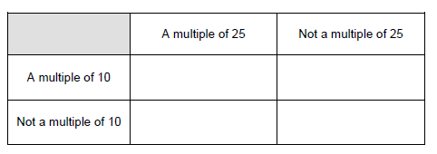

9. Circle the correct answer:

a. The multiple of 10 in the following list is …..

102; 112; 120; 121

1. **Problem solving**

Answer the following:

**Doing calculations involving animals**

1.1 Look at this picture of the animals in the farmyard at the zoo. Then answer the questions about the picture.

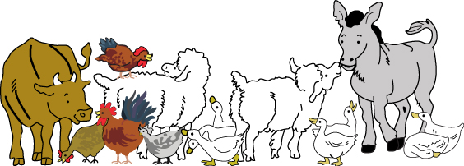

1. How many legs do the animals in the farmyard have altogether?

_______________________________________________________________

1. Count the total number of eyes of all the animals in the farmyard.

_______________________________________________________________

* 1. Sally’s time for a spring race was 12, 32 seconds; Mary’s time was 12, 34 seconds. Who ran the fastest? ___________________
  2. Nosipho buys two packets of potatoes. One has a mass of 6, 68 kg and the other has a mass of 6, 86kg. Which has the lowest mass? ____________

**1.4 Problem-solving involving money**

1.4. 1 Calculate the change from R10, 00 if I spend:

a. R6, 50 : _______________

b. R5, 20 : _______________

1.4.2. Calculate the cost of 3 identical toys if 1 toy costs R12, 34.

____________________________________________________

2. Complete the table to calculate the total value.

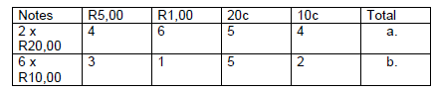

3. Calculate R38, 32 + R7, 82 + R4,00 .

____________________________

_____________________________

4. Jabu wants to buy a T-Shirt for R86,99 and a poster for R25,89.

a. How much will this cost altogether?

_____________________________

_____________________________

b. Jabu only has R100, 00 in his wallet. How much more money does he need?

_____________________________

5. Problem Solving on Division:

a. Sipho changes his R100 note for R5 coins only. How many coins does he get?

Sipho gets _______________ coins.

b. I have to pack 296 apples into 8 boxes. How many apples will there be in a box if each box

contains the same number of apples?

__________________________________________________

c. If I share 123 sweets equally amongst 7 children, how many sweets will each child get?

How many sweets will be left over?

_________________________________________________

1. Two hundred and fifty chickens used to be transported. The farmer put 25 chickens into one box. How many boxes will he need? _________________

_________________

1. 168 trees are planted equally in 12 rows. How many trees are in each row?

__________________

__________________

**Common Fractions:**

**E.g**

**Look at the shapes below:**

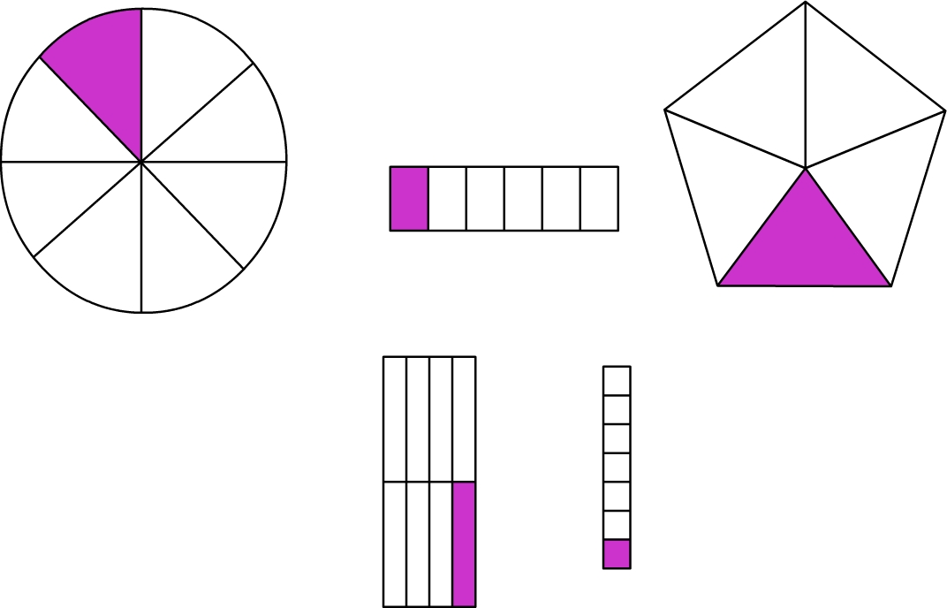

1. **Circle the shapes above with  shaded.**
2. **Cross the shapes above with  shaded.**
3. **Tick the shapes above with  shaded.**

**Answers**

**a) 1st and 4th diagram.**

**b) 3rd diagram.**

**c) 5th diagram.**

1. Answer the following question about the figure given below:

|  |  |  |  |
| --- | --- | --- | --- |
|  |  |  |  |
|  |  |  |  |
|  |  |  |  |
|  |  |  |  |
|  |  |  |  |

1. Into how many equal parts has the above figure been divided? ___________

1. What fraction of the figure has been shaded? _________________
2. What fraction of the figure has not been shaded? __________________
3. Write the following fractions in numerals:

|  |  |  |  |  |
| --- | --- | --- | --- | --- |
| 1. Two thirds |  |  | (c) seven tenths |  |
| 1. Three fifths |  |  | (d) five sevenths |  |

1. Look the fraction wall below to compare the following fractions by using **<, >** or **=** for each one.

|  |  |  |  |  |  |  |  |  |  |  |  |  |
| --- | --- | --- | --- | --- | --- | --- | --- | --- | --- | --- | --- | --- |
| 1 | | | | | | | | | | | | |
|  | | | | | | |  | | | | | |
|  | | |  | | | |  | | |  | | |
|  |  | |  | |  | |  |  | |  | |  |
|  | | | |  | | | | |  | | | |
|  | |  | |  | |  | | |  | |  | |

1. __________ (b) ___________



(c) __________



Use the above fraction wall to check for equivalent fractions

(d) = (e) =



____________________ _______________________

4. Look at the fraction wall and then answer the questions.

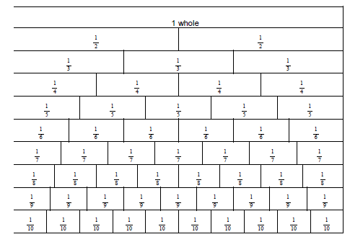

1. Write the fractions below from smallest to biggest.



______________________________

1. How many quarters make a half? ___________________________



1. = ___equals to _________quarters



d. Shade on the fraction wall.

5. Fill in the missing fraction in the sequence.



6. What fraction is shaded? Tick the correct answer.

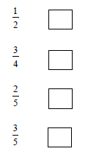

7. Which fraction has the same value as ? Circle the correct answer.



8. The fraction that has the same value as I is …



**Addition of common fractions:**

1. Add the following fractions.

**Example 1**  +  =  Shade 4 wedges, then 2 wedges, then 6 wedges.

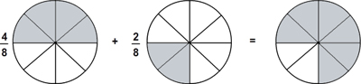

**Example 2 +**



**= =**



1. What is the sum of and ____________



2. Complete...



3. What is equal to? _________________

**Solve problems involving common fractions:**

a. Mandlovu must share 20 oranges equally between 4 bags.

1. How many oranges does she put into each bag? __________________

(ii) What fraction of the oranges goes into each bag? __________________



b. Lauren first eats of a chocolate cake before supper, and then eats another after supper.

(i) What fraction of the chocolate cake did she eat altogether? ____________

____________

(ii) What fraction of the chocolate cake was left? _________________ _________________

1. On Monday Ben picked one sixth of a kilogram of strawberries. On Tuesday he picked two

sixths of a kilogram of strawberries. What is the total mass of the strawberries that Ben picked?

_________________________

_________________________

1. Three fifths of the children at my party like chocolate ice-cream. How many of the 20 children at my party do not like chocolate ice-cream?

_________________________________

________________________________

1. One tenth of the 30 bananas is rotten. How many bananas are rotten?

______________________________

1. Aunty Peggy's 5 grandchildren came to visit her. She shares a bottle of cooldrink equally amongst the 5.

(i) What fraction of cooldrink does each child get? __________________

(ii) Sue gives her cooldrink to Omar. What fraction of cooldrink did Omar get?

_____________________________



1. Of 24 pine trees were chopped down for Christmas. How many trees were chopped down? _____________________________________________

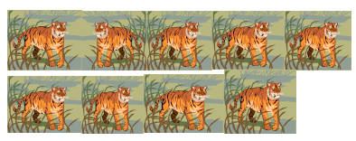

One third of the tigers in the picture above were injured. How many were injured?

______________________________



1. Serena spent of her R60,00 pocket money on sweets and another of her money on a pen.
2. Total amount spent =_________________________________

(ii) Fraction of money left = ________________________________

**CONTENT AREA: SPACE AND SHAPE (GEOMETRY)**

**Recognise and name 2D shapes**

1. Use the names given in the table to name the following polygons.

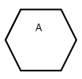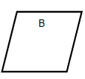

________________ _______________

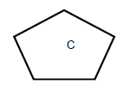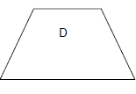

_______________ _______________

2. In this group of shapes below, how many are triangles?

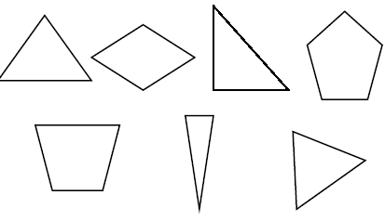

________________ triangles.

3. Study the diagrams and complete the table below.

|  |  |  |  |
| --- | --- | --- | --- |
| **Shape** | **Name** | **How many sides** | **How many corners or angles** |
|  | rhombus | 4 | 4 |
|  |  | 3 |  |
|  | pentagon |  |  |
|  |  |  | 4 |
|  |  | 6 |  |

4. The figure below is made up of triangles of different sizes:

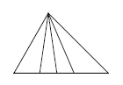

How many triangles are there in the figure above? __________________

**Recognise and name 3D objects**

1. Study the following 3-D objects and complete the table below:

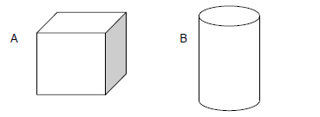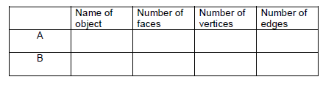

2. Look at the picture of the 3-D object below and complete the table:

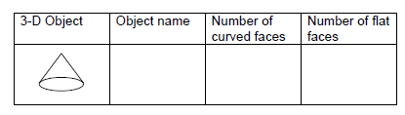

3. Look at the picture of the closed solid 3-D object below and complete the table:

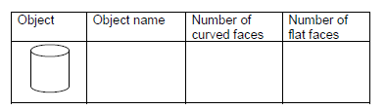

4. Look at the following shape and complete the table:

|  |  |  |  |
| --- | --- | --- | --- |
| Name of object | How many faces? | How many edges? | How many vertices? |
|  |  |  |  |

5. Name the numbered 3-dimensional objects.



5.2

5.1

___________ 5.5

5.3 5.4

6. Look at the following pictures and identify the 3-dimensional objects in each picture.

(Look at the total of marks for each number to help you to know how many objects you have to identify in that picture.)

Choose from the following 3-dimensional objects:

Cube Square prism Rectangular prism Cylinder Sphere

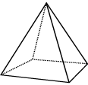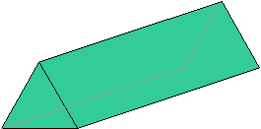

Cone Triangular Prism Square based pyramid Triangular based Pyramid

_______________________

6.1. _______________________



6.2 _______________________



6.3

______________________

_____________________

1. Study the following 3-dimensional object and answer the questions that follow:



7. 1 What do we call this object?

_____________________________

7.2 What 2-dimensional shapes are there in the surfaces/faces of this object?

______________________ _______________________

**Recognise and draw line(s) of symmetry in 2-D shapes**

1. Draw a circle around the letter of the correct answer

Which shape below has a line of symmetry?

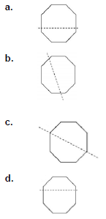

2. Draw all the lines of symmetry in this shape:

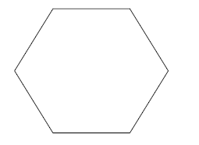

3. Draw in the line(s) of symmetry for those pictures which you think are symmetrical.

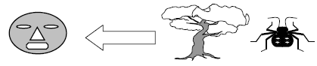

4. List any four capital letters in the alphabet that are symmetrical.

5. Mark the shapes that are symmetrical with an "x".

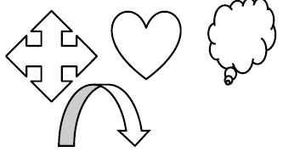

6. Draw the other part of the face to make a symmetrical picture.

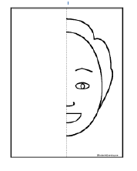

**Identify everyday objects from different views/positions**

1. Match the drawing to the child who drew it.

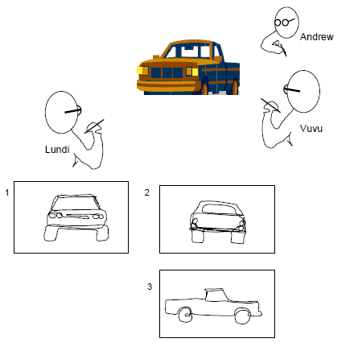

2. *Draw a circle around the letter of the correct answer.*

Andy draws different views of the suitcase.

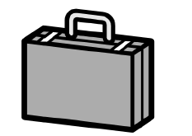

Which view shows the suitcase from the top?

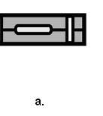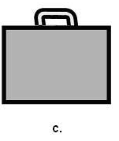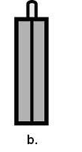

3. Look at this structure made with building blocks:

John has taken photos of these objects from different positions, i.e. from top, front and right side

Complete the following sentences about the views of the above object:

This is the view from the ____________

This is the view from the ­­­­­­­­­­­­­­­­­­­­­­­­­­­­­­__________

This is the _________ view:

____________________________________________________________

**CONTENT AREA: MEASUREMENT**

**Length and Volume**

1. Draw arrows to match column A to column B.

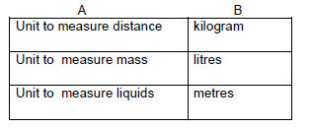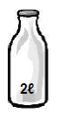

2. Poppy buys a 2 ℓ bottle of milk.

She uses 500 mℓ of milk to bake a cake.

How much milk is left in the bottle? ____________mℓ

3. What is the length of the pencil in mm?

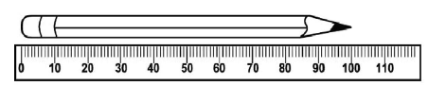

________________________ mm

4. Complete the following:

1. 000 *m* + 400 *m* = ____________ *m* = ____________ *km*

5.Complete the following:

a. 0,5 litres = _______ml

b. 2 cm = ________mm

c. 500 mm = _______m

d. 1 000ml = ______ l

6.

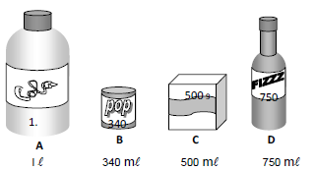

a. Use the letters A, B, C and D to arrange the containers from the one that holds the least to the one that holds the most.

_______________________________________

b. How much more cool drink does the Cola container hold than the Pop can?

_______________________________________

c. How much cool drink do the four containers hold altogether?

__________________________________________

7. Shireen used 2 litres of water for making tea and coffee, 50 litres of water for doing washing and

32 litres of water in her garden. How much water did she use?

_____________________________________________

**______________________GOOD LUCK ______________________**

**GRADE 4 MEMORANDUM**

**CONTENT AREA: WHOLE NUMBERS**

**COUNTING, ORDERING, COMPARING, REPRESENTING, PLACE VALUE AND ROUNDING OFF**:

|  |  |  |  |
| --- | --- | --- | --- |
| **Topic** | **Question** | **Answer** |  |
| **Count forward and backwards** | 1. | a. 3 125; 3 150; 3 175.  b. 6 900; 6 850; 6 800;  c. 4 200; 4 225. |  |
| 2 | a. 939; 942; 945; 948.  b**. 4** 878; 4 876; 4 874; 4 872 |  |
| 3 | a. 4 108; 4 110.  b. 5 985; 5 983 |  |
| 4 | **a** 2 250; 2 300; 2 235**;**  b 9 140; 9 130; 9 100;9 090 |  |
| 5. | 1. 519; 522; 527; 532 2. 8 222; 8 220; 8 210; 8 200 |  |
|  |  |  |  |
| **Order, compare and represent numbers** | 1. | 4100; 4040 4010, 4001, |  |
| 2 | 4180; 4 810, 8140; 8410 |  |
| 3 | 9 650 |  |
| 4 | **a**.5 645    b. 6 790 |  |
| 5 | Five thousand and eighteen |  |
| 6. | a. 4 813     1. 6 016 |  |
| 7 | a. 7 964 **>** 7 946  b. 3 010 **<** 3 110 |  |
|  |  |  |  |
| **Place value** | 1. | **3** 503 = 3 thousands |  |
| 2 | 4 **3**50 = 3 hundred |  |
| 3. | 5 **6**14? = 600 |  |
|  | 7 6**9**4. 90 |  |
|  | 4 202 |  |
|  | 400 – 40 = 360 |  |
|  |  |  |  |
| **Round Off to the nearest 10, 100 or 1000:** | 1. | a. The number 454 rounded off to the nearest 10 is **450** |  |
| 2 | 1. 4 948 rounded off to the nearest 10 ≈ 4 950. 2. 4 948 rounded off to the nearest 100 ≈ 4 900. 3. 4 948 rounded off to the nearest 1000 ≈5 000. |  |
| 3 | R 14, 76 ≈ **R 15.00** |  |
| 4 | R13,99 + R3,14 = R17.13 = **R17.00** |  |
| 5 | Is 1 758 closer to 1 700 or 1 800?= **1 800** |  |
|  | 6 | Round off 676 to the nearest 100: = **700** |  |
|  |  |  |  |
| **Number sentences to describe a problem:** | 1. | a.242 - **221** = 21  b**. 100** ÷ 25 = 4 |  |
| 2. | a. 53  b.12 |  |
| 3. | 23 + 23 +12 = 58  112 ÷ 8 = 14  R 84 ÷ 6 = |  |
| 4. | 35 × 9 = 315 | **Accept any word problem that is mathematically sound** |
| 5. | a. 165 + 145 - 48 = 262  b. 789 - 709 + 207 = 287 |  |
| 6. | a. (6 + 2) x 5 |  |
| 7. | 1. 7 x 3 = 21 **21 ÷ 7= 3 or 21 ÷ 3 = 7**  1. 30 ÷ **6** = 5 **5 x 6 = 30 or 5 x 6 = 30**  1. 48 ÷ **4** = 12 **12 x 4 = 48 or 4 x 12 = 48**  1. 54 + 29 equal to 29 + 54? **True** 2. 67 – 45 is equal to 45 – 67 **False** |  |
| 8 | 78 x 8 = 624 means 624 ÷ 8 = **78** and 624 ÷ 78 = **8** |  |
| 9 | 9 x 4 = 36; **( 36 ÷ 4 = 9 and 36 ÷ 9 = 4)** |  |
| 10 | 2x 3 = 6  3x 2 = 6  6 ÷ 3 =2  6÷2=3 |  |
| 11 | 20 red beads |  |
|  |  |  |  |
| **Addition and Subtraction of whole numbers** | 1. | 1 4 0 7 + 6 8 9 = 2096 | **ACCEPT any method that is mathematically sound.** |
| 2. | 8 3 2 6 - 7 6 8 = 7558 |
| 3. | 6 832 + 2 594 = 9426 |
| 4. | 3 648 – 555 = 3093 |
| 5. | 5 321 + 492 = 5813 |
| 6. | 3 468 – 545 = 2923 |
| 7 | a. 3 846 + 3 217 = 7063  b. 2 752 + 4 356 = 7108 |
| 8 | . 5 726 – 1 334. = 4392 |
| 9 | 2366 |
| 10 | 9000 – 9 = 8991 |

**CONTENT AREA: PATTERNS, FUNCTIONS AND ALGEBRA**

**Numeric and geometric pattern**

|  |  |  |  |
| --- | --- | --- | --- |
| **Topic** | **Number** | **Answer** |  |
| **Number Patterns** | 1. | a. 11; 16; 22  b. 16; 21; 26 |  |
|  | 2. | c. yes  d. multiples of 20 or even numbers |  |
|  | **3** | 1 + 3 + 5 + 7 + 9 = 25 |  |
|  | 1. | 34 + 11 = 45  82 + 11 = 93  67 + 11 = 78  74 + 11 = 85 |  |
|  | 2. | a. 23 + 4 = 27  37 – 4 = 33  43 + 4 = 47   1. - 4 = 53   b.49 +10 = 59  119 – 10 = 109  159 + 10= 169  229 – 10 = 219 |  |
|  |  |  |  |
| **Investigate and extend numeric and geometric patterns** | 1. |  |  |
|  |  | 8 |  |
|  |  | a.  b.South Africa |  |
|  |  |  |  |
|  |  |  |  |
| **Relationships or rules in words:** |  | 20 x 6 = 120 |  |
|  | 2. | a. $x+5$ b $. x+10$ c. $y x 3$ |  |
|  | 3. | The sum of two numbers plus four. |  |
|  |  |  |  |
| **Multiplication** | 1 | 56 x 24 =1344 | **ACCEPT any method that is mathematically sound.** |
|  | 2 | 37 x 45 = 1665 | **ACCEPT any method that is mathematically sound.** |
|  | 3 | 6 x 5 = 30 |  |
|  | 4 | 46 x 32  46  X 32  12 (2 x6)  80 (2x40)  180 (6 x30)  1200 (30x40)  1 472 |  |
|  | 5 | 24 x 64  64  96  + 1440  1536 |  |
|  | 6. | : 20 x 8 = **8** x 20 |  |
|  | 7. | 12 x 11 = 132 |  |
|  | 8. | If 9 x 8 = 72 then **8** x 9 =72 |  |
|  |  |  |  |
| **Division of at least whole 3-digit by 1-digit numbers:** | 1. | a. 135 ÷ 9 = 15  b. 296 ÷ 8 = 37  c. 722 ÷ 4 = 180 remainder 2 | **ACCEPT any method that is mathematically sound.** |
|  |  | ( i) 217 ÷ 7 = 31  (ii)396 ÷ 2 = 198 | **ACCEPT any method that is mathematically sound** |
|  |  | 500 ÷ 5 > 100 ÷ 10 |  |
|  |  | False |  |
|  |  | 125 ÷ 5 = 25  333÷ 3 = 111  450 ÷ 9 = 50 |  |

**TIME:**

|  |  |  |  |
| --- | --- | --- | --- |
| **Topic** | **Number** | **Answer** |  |
| **Reads, tells and write analogue, digital and 24-hour time** | 1. | 14:00 |  |
|  | 2. | 07:45 in analogue | Accept any accurate drawing. |
|  | 3. | 5 hours 30 min |  |
|  | 4. | 5hours 15min |  |
|  | 5.1 | a) 45min  b) 30min  c) 1hour/30min |  |
|  | 5.2 | a)pm  b)pm  c)am |  |
|  |  |  |  |
| **Solve problems involving calculation and conversion between time units** | 1. | a) 100  b) 36  c) 30  d)120 |  |
|  | 2. | 1min = 60 sec  2min = 120 sec  5min = 300 sec |  |
|  | 3. | 3.1 Tick the 2nd and 20th on the calendar  3.2 Mark  3.2 18 days |  |
|  | 4. | 4.1 Tick the 17th and 23rd on the calendar  4.2 John  4.3 144 hours |  |

**CONTENT AREA: DATA HANDLING**

|  |  |  |  |
| --- | --- | --- | --- |
| **Organise and record data using tallies and tables** | **Number** | **Answer** |  |
|  | 1. | 12  llll llll llll llll l apples  2  llll |  |
|  | 2. | llll llll llll llll llll llll l |  |
|  | 3. | d. Amina llll 4  Lucky lll 3  Sam llll 5  Tammy ll 2  e.Sam  f. 14 |  |
|  |  |  |  |
| **Read and interpret data presented in graphs** | 1. | 1.1. 180kg  1.2. 2  1.3. 45 + 30 = 75  1.4. 180 + 105 + 75 + 45 + 30 = 435 |  |
|  | 2. | 2.1. 30  2.2. Peanuts  2.3. Morogo |  |
|  | 3. | a) 5  b) 35 |  |
|  | 4. | b) kites  c) 9  d) 5 |  |

**Multiples of single –digit numbers to at least 100 and Problem solving**

|  |  |  |  |
| --- | --- | --- | --- |
| **Multiples** | **Number** | **Answer** |  |
|  | **1.** | 18; 24; 39 |  |
|  | **2.** | no |  |
|  | **3.** | 8; 16; 24; 32; 40; 48 |  |
|  | **4.** | 35 |  |
|  | **5.** | 42; 48; 54 |  |
|  | **6.** | 7 |  |
|  | **7.** | 30 |  |
|  | **8.** | 400 multiple of 10 and 25  410 multiple of 10 but not a multiple of 25  415 not a multiple of 10 and 25  425 multiple of 25 but not a multiple of 10 |  |
|  | **9.** | 120 |  |
|  |  |  |  |
| **Problem solving** | **1** | * 1. a) (11 x 2) + (4 x 4) = 38   b) 15 x 2 =30 |  |
|  |  | * 1. Sally |  |
|  |  | * 1. 6, 68 |  |
|  | **1.4** | 1.4.1  a) R3,50  b)R4.80  1.4.2 R37,02 |  |
|  | **2.** | a) R67, 40  b) R 77, 20 |  |
|  | **3.** | a) R38, 32 + R7, 82 + R4, 00 = R50.14 |  |
|  | **4.** | a) R112,88  b) R12, 88 |  |
|  | **5.** | a) 20  b) 37  c)17 and 4 left  d) 10  e) 2016 |  |

**Common Fractions**

|  |  |  |  |
| --- | --- | --- | --- |
| **Common Fractions:** | **Number** | **Answer** |  |
|  | **1.** | a) $\frac{4}{20}$ b) $\frac{16}{20}$ |  |
|  | **2.** | a)  b)  c)  d) |  |
|  | **3.** | 1. = 2. < 3. >   = = |  |
|  | **4.** | a) ; ; ; ;    b.2  c. 1 quarter  d. Shade $\frac{4}{6}$ | Accept the correct shading |
|  | **5.** | $$\frac{13}{26}$$ |  |
|  | **6.** | $$\frac{3}{5}$$ |  |
|  | **7** | $$\frac{3}{4}$$ |  |
|  | **8** | $\frac{2}{3}$ |  |
|  |  |  |  |
| **Addition of common fractions:** | **1.** | $\frac{4}{4}$ or 1 |  |
|  | **2.** | $\frac{5}{7}$ |  |
|  | **3** | $\frac{6}{4}$ |  |
|  |  |  |  |
| **Solve problems involving common fractions:** | **a)** | 1. 5 oranges per bag   (ii) $\frac{1}{5}$ |  |
|  | **b)** | i) $\frac{2}{8}$ (ii) $\frac{6}{8}$ |  |
|  | **c)** | $\frac{3}{6}$ or $\frac{1}{2}$ |  |
|  | **d)** | 8 children |  |
|  | **e)** | 3 bananas |  |
|  | **f)** | $\frac{1}{5}$ |  |
|  | **g)** | $$\frac{2}{5}$$ |  |
|  | **h)** | 16 |  |
|  | **i)** | 3 tigers |  |
|  | **k)** | 1. R 24.00   (ii) $\frac{3}{5}$ |  |

**CONTENT AREA: SPACE AND SHAPE (GEOMETRY)**

|  |  |  |  |
| --- | --- | --- | --- |
| **Recognise and name 2D shapes** | **Number** | **Answer** |  |
|  | **1.** | Hexagon    **Parallelogram**    **Pentagon**    **Trapezium** |  |
|  | **2** | 4 triangles. |  |
|  | **3** | |  |  |  |  | | --- | --- | --- | --- | | **Shape** | **Name** | **How many sides** | **How many corners or angles** | |  | rhombus | 4 | 4 | |  | triangle | 3 | 3 | |  | pentagon | 5 | 5 | |  | rectangle | 4 | 4 | |  | hexagon | 6 | 6 | |  |
|  | **4.** | 9 triangles |  |
|  |  |  |  |
| **Recognise and name 3D objects** | **1.** | A - Cube = 6 faces = 12 vertices = 8 edges  B – Cylinder = 3 faces = 0 vertices = 0 edges |  |
|  | **2** | Rectangular prism = 0 curved faces = 6 flat faces |  |
|  | **3.** | Cylinder = 1 curved faces = 2 flat faces |  |
|  |  | 2 faces; 0 edges; 1 vertices |  |
|  |  | 5.1 Cylinder  5.2 Rectangular pyramid  5.3 Rectangular prism  5.4 Cone  5.5 Sphere |  |
|  |  | Square based pyramid  Cube    triangular prism  Cylinder    Cone |  |
|  |  | 7.1 pyramid  7.2 Rectangle and triangle |  |
|  |  |  |  |
| **Recognise and draw line(s) of symmetry in 2-D shapes** | **1.** | C |  |
|  | **2,** |  | Accept any accurate drawing |
|  | **3** |  | Accept any accurate drawing |
|  | **4** | A B C D E H M O U V W X Y |  |
|  | **5** | X  X |  |
|  | **6.** |  | Accept any accurate drawing |
|  |  |  |  |
| **Identify everyday objects from different views/positions** | **1** | * 1. Picture 1 drawn by Lundi   2. Picture 2 drawn by Andrew   3. Picture 3 drawn by Vuvu |  |
|  | **2.** | View A |  |
|  |  | view from the **front**  view from **the ­­­­­­­­­­­­­­­­­­­­­­­­­­­­­­top** |  |

**CONTENT AREA: MEASUREMENT**

|  |  |  |  |
| --- | --- | --- | --- |
| **Length and Volume** | **Number** | **Answer** |  |
|  | **1.** |  |  |
|  | **2.** | 1liter,500mℓ or 1500 mℓ |  |
|  | **3.** | 100 mm |  |
|  | **4** | 5 000 *m* + 400 *m* = 5400 *m* = 5,4 *km* |  |
|  | **5.** | a. 0,5 litres = 500ml  b. 2 cm = 20 mm  c. 500 mm = 50 m  d. 1 000ml = 1ℓ |  |
|  | **6.** | B= 340 mℓ, C= 500 mℓ, D= 750 mℓ, A= 1ℓ  960 mℓ  2 ℓ 590 mℓ or 2,590 ℓ |  |
|  | **7.** | 84 ℓ of water |  |