
PROVINCIAL ANA INTERVENTION PROGRAMME

MATHEMATICS ANA PAST EXAMPLARS AND PAST QUESTION PAPERS

2014

GRADE 6

ANNUAL NATIONAL ASSESSMENT 2014
ASSESSMENT GUIDELINES
MATHEMATICS
GRADE 6
INTRODUCTION

The 2013 cycle of Annual National Assessment (ANA 2013) will be administered in all public and designated1 independent schools from 10 to 13 September 2013. During this period all learners in Grades 4-6 will write nationally set tests in Mathematics. The results will be used to report progress related to achieving the goals set in the Action Plan 2014, Towards Schooling 2025.
The ANA tests will be written during the third school term and, therefore, the Department of Basic Education (DBE) has developed Assessment Guideline documents for each grade and subject (Mathematics) outlining the minimum curriculum content that must be covered by all learners prior to the writing of the test. The Assessment Guidelines define the scope of work that will be covered in the test for each grade and subject.
INTERMEDIATE PHASE

In Grades 4-6, the tests will cover work that is prescribed for the first three-quarters of the school year. The Assessment Guidelines are arranged in three columns: Content Area; Concepts and Skills; and Content to be assessed. It is important to note that the ANA 2013 Assessment Guidelines do not imply that the delimited scope is all that must be taught and learnt during the school year. Instead, the Assessment Guidelines provide the minimum curriculum requirements that must be covered by the end of the third school quarter.
Teachers are expected to use these Assessment Guidelines together with the other resources for their teaching and assessment programmes.
To support school-based assessments and also ensure that learners gain the necessary confidence to participate with success in external assessments, exemplar test questions were developed that teachers can use in Mathematics lessons. The exemplar test questions were developed based on the curriculum that covers terms 1, 2 and 3 of the school year. The exemplars, which include the ANA previous question papers, supplement the school-based assessment that learners must undergo on a continuous basis and does not replace the school based assessment. The exemplars are designed to illustrate different techniques or styles of assessing the same skills and/or knowledge. Exposure to a wide variety of questioning techniques or styles gives learners the necessary confidence to respond to different test items. By using the ANA exemplars as part of their teaching resources, teachers will help learners become familiar with different styles and techniques of assessing. With proper use, the exemplars should help learners acquire appropriate knowledge and develop relevant skills to learn effectively and perform better in subsequent ANA tests. It is important to ensure that learners eventually get sufficient practice in responding to full tests of the type of the ANA model test.
How to use the exemplars
While the exemplars for a grade and a learning area have been compiled into one comprehensive set, the learner does not have to respond to the whole set in one sitting. The teacher should select exemplar questions that are relevant to the planned lesson at any given time. Carefully selected individual exemplar test questions, or a manageable group of questions, can be used at different stages of the teaching and learning process as follows:
- At the beginning of a lesson as a diagnostic test to identify learner strengths and weaknesses.
- During the lesson as short formative tests to assess whether learners are developing the intended knowledge and skills as the lesson progresses and ensure that no learner is left behind.
- At the completion of a lesson or series of lessons as a summative test to assess if the learners have gained adequate understanding and can apply the knowledge and skills acquired in the completed lesson(s).
- At all stages to expose learners to different techniques of assessing or questioning.

CONTENT AREA: NUMBERS, OPERATIONS & RELATIONSHIPS
RECOGNISE, REPRESENT, DESCRIBE AND COMPARE WHOLE NUMBERS TO AT LEAST
9-DIGITS.
Expanded Notation:
Examples
Write the following numbers in the expanded notation.
- 297 348
(2 x100000)+(9x10000)+(7x1000)+(3x100)+(4x10)+(8x1)
200000 + 90000 +7000 +300+40+8
.
- 300 901 472
(3x100000000)+(9x100000)+(1x1000)+(4x100)+(7x10)+(2x1)
3000000000 +900000+1000+400+70+2

Activities:
Circle the letter of the correct answer in QUESTION 1-2.
1.1 Which number is represented by (3 x 10 000) + (40 x 100) + (900) + (15 tens) + (7 x 1)?

A 349 570 B 34 957 C 35 057 D 34 579

1.2. Which number is represented by ?
50 000 000 + +190 000 + 500 + 80 + 7 = 56 190 587
______________
1.3. Complete:
3 567 439 = (3 × _____) + (5 × _____) + (6 × _____) + 7 000 + 400 + 39

1.4. Write 42 631 627 in expanded notation.
_______________________________________________________________

2. Write numbers to word or words to numbers:
Example:
Write numbers to words or words to numbers:
Examples
- 451 267
Four-hundred and fifty one thousands, two hundred and sixty-seven.
- Twenty two million and three.
22 000003
Activities:
2.1 The number, three hundred and fifty nine thousand eight hundred and three, can be written as:

A 359 308 B 395 803 C 359 803 D 593 803

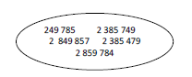
2.2. Underline the number two million, three hundred and eighty-five thousand seven hundred
and forty-nine.

2.3 Write the following number in words:
234 709: _______________________________________________________________

2.4. Write the number in digits.
Four million two hundred and eighty three thousand one hundred and sixty four.
_________________________________

3. Counting and Ordering of numbers:
Example:
- Small to big 2 00808; 800028; 280008; 082008;
082008; 200808; 280008; 800028
- Big to small 132 365 ;653 132 ; 356 132 ; 132 563
653 132; 356 132; 132 563; 132 365
Arrange the given numbers below from the smallest to the biggest and from the biggest to the smallest.
Activities:
3.1 Choose any two of the given numbers that are bigger than 1 million.

967 204; 198 764, 23; 998 537; 19 234 556; 3 999 672

3.2 Which number is represented by the D on the following number line?
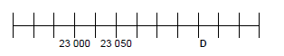

3.3 Arrange the given numbers in descending order of size.
212 143 123 243 413 123 342 123
_______________________________________________________________

3.4. The following number of spectator tickets were sold at the Olympics:
1 770 239 for swimming, 68 945 for weightlifting, 1 707 239 for gymnastics and 2 165 001 for athletics. Which sport was the most popular?
__________________________________

3.5. Which number is exactly halfway between 23 450 and 23 500? ______________________________

3.6 In the grid below shade the number that is 2 million more than 457 342 109.
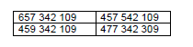

3.7. Draw a circle around the letter of the correct answer.
Which monthly salary is the largest?
a. R780 299
b. R708 219
c. R788 210
d. R788 209

4. RECOGNISE PRIME NUMBERS TO AT LEAST 100.
Prime Number:
A prime number is a number that can only be divided by one and itself.
Examples
1;2;3;5;7;11;13;17;…….

Activities:
Circle the letter of the correct answer.
41. Which number is a prime number?

A 21 B 9 C 27 D 13

4.2. List all the prime numbers between 27 and 35.
______________________________________

4.3. Underline the prime number.
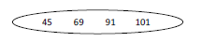

4.4. 5, 57; 27; 72; 36; 61; 81; 45
From the numbers above, choose:
4.4.1. a prime number: _________________________
4.4.2. a number which is the product of two prime numbers.
______________________________________

4.5. From the list of numbers below, write two prime numbers.
4; 5; 9; 11; 15
________________ and __________________

4.6. Circle the prime number in the following:

27; 29; 33; 39

4.7. The prime number in the following list is …

19 21 33 39

5. RECOGNISE THE PLACE VALUE OF WHOLE NUMBERS TO AT LEAST 9-DIGIT
NUMBERS.
Place Value: It is the value of a number by virtue of its position
Examples
- What is the place value of the underlined digit?
2 903 786 Thousands
- Write down the value of the underlined digit.
2 903 786 3 000 or Three thousand

Activities:
5.1. Write the value of the underlined digit.
a. 273 503: _________________________________

b.5 348 503: _________________________________

5.2 What is the value of the underlined digit in 64 379 568?

A 4 x 10 000 000 B 4 x 100 000 C 4 x 1 000 000 D 40 000 000

5.3 What is the place value of the underlined digit in 76 490 213?

A Hth B TTh C TM D M

5.4 Which number has a 7 in the thousandth's place?

A 3, 17 B 8, 78 C 23,007 D 0,070

5,5 What is the place value of the underlined digit in 357 219 432?

A 10 000 000 B 1 000 000 C 100 000 000 D 100 000
5.6 What is the value of the digit 2 in the number 127 856 403?
_____________________________________

5.7 What is the place value of the underlined digit in 205 504 379?
___________________________________

5.8 Write a number with nine digits that contains the digit 4 once only, so that the place value of the 4 is four hundred thousand. __________________________________

5.9. These are the actual populations of two countries:
Country A: 21 368 071
Country B: 157 826 403
- How many people are indicated by the digit 5 in the number for the Country B?
_____________________________

b. How many people are indicated by the digit 3 in the number for the Country A?
_____________________________

5.10. Add the four amounts, represented by the underlined digits.
R63, 04; R46, 30; R4, 36 and R43, 06
______________________________________________________

6. ROUND OFF TO THE NEAREST 5, 10, 100, 1000, 100 000 or 1 000 000
Examples
- Nearest 5 → 28 = 30
- Nearest 10 → 487 = 490
- Nearest 100 → 23410 = 23 400
- Nearest 1000 → 123 456 789 = 123 457 000

Activities:
Circle the letter of the correct answer in QUESTION 1-3.
6.1. Round 36 233 off to the nearest 5.

A 36 230 B 36 235 C 36 240 D 36 200

6.2. Which of the following numbers is the closest to 10 300?

A 10 400 B 10 030 C 11 000 D 10 350

6.3. Which is the best estimation of the number of South African soccer fans?

A 1 500 B 40 000 C 150 000 D 1 208 367

6.4. Round 24 059 off to the nearest 100. ______________________

6.5. Thabo rounded the number of marbles to the nearest 5. His answer was 340. Write down all
the possible numbers for the actual number of marbles. ______________________

6.6. I bought an article for R46,38. The cashier did not have any one or two cent coins. If rounded
down to the nearest 5c, how much will I be charged for the article?
____________________________________________

6.7. Round off 3647 to the nearest 10. ________________________

6.8. Write your answers in the spaces provided.

6.8.1 Round off 5 683 to the nearest 5. ____________________
6.8.2 Round off 5 683 to the nearest 1 000. ____________________

6.9. Complete:
6.9.1 4 633 rounded off to the nearest 100 is ______________

6.9.2 4 687 rounded off to the nearest 1000 is ______________

7. ADDITION AND SUBTRACTION OF WHOLE NUMBERS:
Example:

7.1. Add: 6 1 4 7
+ 3 6 8 9

7.2. Calculate:

7.2.1. 1 678 + 8 694 7.2.2. 3 784 – 1 231
______________ ______________
______________ ______________
______________ ______________

7.2.3 5 2 3 4 7.2.4 4 8 9 9 5 3
4 1 4 2 3 – 3 4 8 6 5 1
+ 5 2 3 1 2
___________
__________

7.3. The following spectator tickets were sold at the Olympics. 1 625 407 for gymnastics, 68 945 for weightlifting, 2 165 001 for athletics and 770 239 for swimming.

7.1. How many tickets were sold altogether?
________________________________________________
7.2. How many more tickets were sold for athletics than for swimming?

__________________________________________________

7.4 Calculate using columns.

7.4.1. 3 423 567 + 766 678 + 2 378 487

___________________________
___________________________
___________________________
___________________________

7.4..2. 3 032 512 – 1 753 769
_____________________
_____________________
____________________

7.5 There are 41 295 spectators at a soccer match. If 23 985 were men and 11 378 were women,
How many children attended the match?
_________________________________
_________________________________
_________________________________

7.6. Complete the following by using compensation.
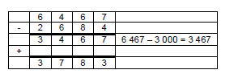
6 467 – 2684

7.7 Calculate the difference between 236 498 and 1 302 301.
____________________________________
____________________________________
____________________________________
____________________________________

7.8 Calculate the missing number in 354 378 + ________________ = 1 503 674.

7.9 A farmer had 2957 sheep. During the winter 134 died and in spring 813 lambs were born.
How many sheep were there then on the farm?
____________________________________
____________________________________
____________________________________
____________________________________

8. MULTIPLICATION OF A 4-DIGIT NUMBER BY A 2/3-DIGIT NUMBER ( IN COLUMNS):
Example:
- 134 X 48

1 3 4
X 4 8
-----------
1 0 7 2
+ 5 3 6 0
------------
6 4 3 2
------------

Activities:

8.1. A farmer can pack 2 139 oranges into a crate. How many oranges can be packed into 428
crates?
_________________________________
_________________________________
_________________________________
_________________________________

8.2. Calculate the product of 7 876 and 393.
________________________________
________________________________
________________________________
________________________________

8.3. A normal, healthy adult heart beats about 78 beats per minute.

- How many times will a heart beat in half an hour?
_______________________________

b. How many times will a heart beat in one hour?
__________________________________

8.4. Determine the missing number in _________ ÷ 879 = 536.
____________________________
__________________________

8.5. There are 253 boys on a camp. If another 189 boys join the camp, there will be an equal
number of boys and girls. How many learners are on the camp?
_____________________________
_____________________________
_____________________________

8.6. Multiply: 1 236 x 365
____________________________________________________________
____________________________________________________________
____________________________________________________________
____________________________________________________________
____________________________________________________

8.7. Grade 6 learners had to multiply 407 and 64. Below are the calculations done by three
learners in the class. Which calculation was done correctly?

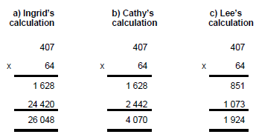

Which learner did the correct calculation?
________________________________

9. DIVIDE A 4-DIGIT NUMBER BY A 2/3-DIGIT NUMBER (USING LONG DIVISION):

7 2

1 2 8 6 4
- 8 4 0
2 4
- 2 4
0

9.1. Divide: 7 650 ÷ 25
____________________________________________________________
____________________________________________________________
____________________________________________________________
____________________________________________________________
____________________________________________________________

9.2. Calculate the remainder if 284 650 is divided by 475.
__________________________
__________________________
__________________________
__________________________
___________________________

9.3. Calculate: 8 250 ÷ 50
______________________
______________________
______________________
______________________
______________________

9.4. During a school excursion 785 learners were transported in busses. How many busses did they use to transport all the learners if each bus transported 65 learners?
_________________________________
________________________________
________________________________

10. RECOGNISE MULTIPLES AND FACTORS OF 2-DIGIT AND 3-DIGIT WHOLE NUMBERS.
Example:
Examples
- Write down the first five multiples of 12.
12; 24; 36; 48; 60
- List all the factors of 36.
1;2;3;4;6;9;12;18;36
Activities:
10.1. The multiple of 10 in the following list is …

102 112 120 153

10.2. Write down all the factors of 24.
__________________________________________

10.3. Complete the following:
10.3.1 The third multiple of 12 is
__________________________________________________________
10.3.2 The factors of 30 are
______________________________________________________________

10.4. Circle the letter of the correct answer in QUESTION 10.4.1- 10.4.3.
10.4. 1. Which number is not a factor of 36?

A 3 B 4 C 8 D 18

10.4. 2. Which number between 12 and 144 is a multiple of 12?

A 12 B 96 C 106 D 46

10.4. 3. Insert the missing factor of 12: 2, _______, 12, 3, 6, 4

A 5 B 1 C 7 D 8

10.5. I count in multiples of 16, up to 160.
10.5.1. Will I count the number 32?
_____________________

10.5.2. Will I count the number 144?
____________________

10.6. Complete the pattern 256; 512; 1 024; __________ ;__________; __________

10.7. Write down the multiple of 7 between 44 to 54.
__________________________________________
10.8. List all the factors of 225.
_______________________________________________

10.9. 1 , 2 , 4 , 16 and 32 are 5 of the 6 factors of 32. Write down the missing factor.
_____________________________

10.10. List the first three multiples of 21.
______________________________________

10.11. Find the lowest common multiple of 12 and 36.
____________________________________

11. PROPERTIES OF WHOLE NUMBERS USING COMMUTATIVE,ASSOCIATIVE AND DISTRIBUTIVE
Example:
Commutative
A + B = B + A
46 + 89 = 89 + 46
135 = 135
Associative
A + (B +C) = (A + B) + C
23 + (52+76) = (23 + 52) + 76
23 + 128 = 75 + 76
151 = 151
Distributive
A(B + C) = AB + AC
2(3+5) = (2x3) + (2x5)
6 + 10 = 6 + 10
16 = 16

Activities:
THE ADDITIVE PROPERTY OF 0 AND 1.

11.1. 578 = ______ + 578
11.2. 47 893 - ______ = 47 893

11.3. Complete the following number sentence.
0 + 95 = ____ and 95 – 0 = ____ therefore 0 + 95 ____ 95 – 0

11.4. Complete the sentence.
When we add zero to a number, the number is:
________________________________

11.5. 24 367 x 0 + 1 = ___________

11.6. 47 983 x ______ = 47 983

11.7. True or false?
When we multiply a number by 1, the answer is always equal to the original number.
__________________________

12. RECOGNISE AND USE DIVISIBILITY RULES FOR 2, 3, 4, 5, 10, 100, AND 1000.

  - Circle the letter(s) of the incorrect statement(s).

A. 45 + 39 = 39 + 45
B. 45 – 39 = 39 – 45
C. 9 x 7 = 7 x 9
D. 20 ÷ 5 =5 ÷ 20

12.2. True or false?
12.2.1 All even numbers are divisible by 2. ___________________

12.2.2. Numbers ending in 00 are divisible by 25. ________________

12.2.3. 5 is a factor of 105. __________________

12.3. Draw a circle around the letter of the correct answer.
Which set of numbers divides exactly into 25?

a. 5; 1; 25 b. 5; 7; 10 c. 5; 1; 7 d. 5; 3; 2

12.4. Circle the number that is not divisible by the number in the box in each of the following:

12.4.1. 2 12; 16; 17; 28

12.4.2. 5 52; 65; 100; 205

- MULTIPLE OPERATIONS WITH WHOLE NUMBERS:
Example

a) 12÷(4+2)×5 =
12 ÷ 6 x 5
2 x 5
10
b) 18 + 20 – (12 ÷ 4) x 3 =
38 – 3 x 3
38 – 9
29

Activities:

Circle the letter of the correct answer in QUESTION 13.1 - 13.3.
13.1. Calculate: (58 +12)- (33 - 19)

A. 56 B. 18 C. 84 D. 9

13. 2. What is the value of B if 21 - 6 = B – 21?

- 15 B. 27 C. 36 D. 21

13. 3. Which sum does not give an answer of 37?

- 6 x 5 + 7 B. (6 x 5) + 7 C. 6 x (5 + 7) D. (6 x 5 + 7)

13.4. Calculate:

13.4. 1. 2 + 3 x 4 = _________________

13.4. 2. 2 x 4 + 3 x 2 = _________________

13.4. 3. 4 + 8 ÷ 2 – 4 = __________________

13.4. 4. 26 – 10 + 6 = ____________________

13.5. Insert an operational sign to make the following number sentence true.
32 - 4 Ж 7 = 4
___________________

13.6. Joe uses his calculator to perform a certain calculation. He then makes a mistake by
multiplying the number by 10 instead of dividing by 10. The calculator answer is 9000.
What should the original correct answer have been?
______________________________

13.7.1. Calculate: 2 010 x (20 + 4) 13.7.2. 197 + (10 x 7) ÷ 5
_________________ ________________
_________________ _________________
__________________ __________________
__________________ __________________
13.8. Calculate: 18 + (3 x 8) ÷ 6
______________________
______________________
______________________

14. PROBLEM SOLVING QUESTIONS

Activities

14.1. Mr Peterson buys a chocolate for R3,45 and sells it for R5,50.

    - How much money did he make by selling the chocolate?
________________________________

    - How much profit can he make if he sells 67 chocolates?
__________________________________________________

    - What will his loss be if he has to sell 15 chocolates for R2,95 each?
______________________________________________________

14.2. A shop holds a sale giving a 10% discount on all the goods.
What should I pay for a pair of jeans marked R250?
_______________________
________________________
________________________

14.3. There are 1 295 spectators at a soccer match. There are four times as many adults as there
are children. How many of the spectators are children and how many are adults?
_______________________________
_______________________________
_______________________________

14.4. A car travels at a constant speed of 120 km per hour. How far will it travel in 12,5 hours?
___________________________
__________________________

14.5. Jacob has a part-time job as a packer in a supermarket. He earns R 9,50 per hour of work. If
one working day is 8 hours, how much will he earn in 7 days?
___________________________________
___________________________________
___________________________________

  - The rand – dollar exchange rate is quoted at 'R 7,67 to the dollar'.
For how much can you exchange the $35 which your aunt in New York sent you?
__________________________________
__________________________________
__________________________________

  - Dr Mololo travels 90 km to the hospital. For every 10 km that she travels, her car uses 2 litres of petrol. How many litres of petrol does the car use to drive to the hospital?
_________________________________________________________
_________________________________________________________
_________________________________________________________

14.8 11 copies of a book cost R330. How much will 6 copies of the same book cost?
_________________________________________________________
_________________________________________________________
_________________________________________________________

  - Last holidays we travelled by car to visit my grandmother who lives 1 248 km away. We
stopped to fill up petrol after travelling 569 km.
14.9.1. How much further from the filling station did we have to travel to reach grandmother’s house?
_____________________________________________________________
_____________________________________________________________
_____________________________________________________________
14.9.2. Travelling a further 385 km after filling up, we stopped for the night at a hotel. How far had we travelled from home?
_____________________________________________________________
_____________________________________________________________ _____________________________________________________________

  - Mr Smith has R 60 000 and pays for the following items.
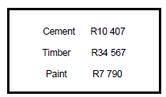

How much change will he have left? _______________________

- RECOGNISE AND USE EQUIVALENT FORMS OF NUMBERS INCLUDING:
COMMON FRACTIONS; DECIMAL FRACTIONS AND PERCENTAGES.

Examples
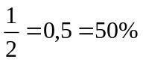

Activities

15.1 Fractions, Decimal and Percentage
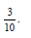
15.1.1. Circle the number that has the same value as
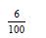
3%; 30%; 0,03;

15.1.2. The fraction that has the same value as 0,6 is …
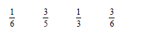

15.1.3. Which percentage has the same value as 0,75?

A 7,5% B 0,75% C 75% D 5,7%

15.2. Which percentage is indicated by the shaded part of the diagram below:
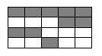

A 10% B 50% C 5% D 0,5%

15.3. Write down all the equal pairs of numbers in the frame from the diagram below:
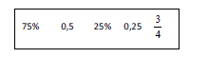

__________________ _______________

15.4. Write 45% as a fraction in the simplest form.
__________________________________

15.5. Complete the following table by filling in the correct values.
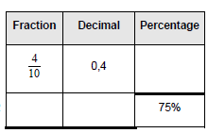

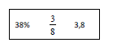
  - Rewrite the following numbers as decimals in descending order:

_______________; ________________; ______________

  - Write the following numbers in the correct places on the given number line.
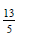
15.7.2.

17.7.3 4, 4
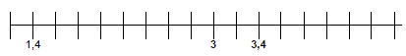

  - Draw straight lines to match the fractions with the correct percentages and/or decimal
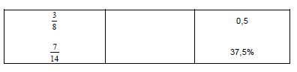
fractions.

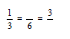

  - Complete the following:
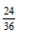
_____

  - Simplify: = ____________

15.11. Replace with the correct relationship sign ( >; < or =)
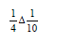
15.11.1. _________

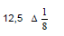
15.11.2.
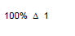
_________

15.11.3. __________

15.12.

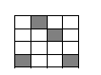

Write the shaded area in the above diagram as:

15.12.1. a percentage ______________

15.12.2. a decimal fraction ______________

15.12.3. a common fraction ______________

15.13. You obtained 27 out of 50 for a Maths test. What percentage did you get?

__________________________________

15.14. Peter obtained 68% for a maths test. The question paper counted 50 marks.
How many marks did he get of the 50?

__________________________________________________

15.15. 10% of 180 is equal to

____________________________________________

15.16. Complete the following:
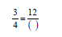

_____________
15.17. Pule ate of his chocolate. Sam has an identical chocolate and ate of his. Who ate the most chocolate?
__________________________________________________

15.18. Sithole’s Motors sold of 42 vehicles during the month of May. How many vehicles did they sell in May?
_________________________________________________

- ADD AND SUBTRACT COMMON FRACTIONS AND MIXED NUMBERS:
Example:
Addition
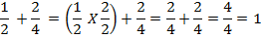

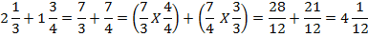
Subtraction
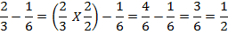

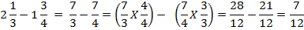

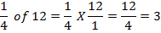

Activities:
  - Calculate and give the answers in the simplest form.
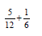
16.1.1 ___________________
___________________
___________________
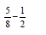
16.1.2 _____________________
______________________
_______________________

  - Solve the following:
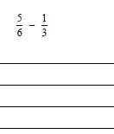
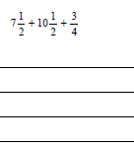
16.2.1 16.2.2

  - Calculate and write your answer as a mixed number:
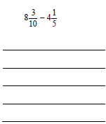
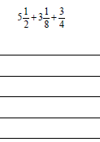
16.3.1 16.3.2

16.4 Determine the missing number.
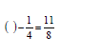
16.4.1.
_____________
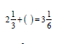

16.4.2.
_______________

16.5. Peter ate and Kangalani ate of a pizza. Which fraction of the pizza is left for
Amy?

_____________________________
____________________________
____________________________

16.6. There are 960 learners at a school. of the learners are absent.
How many learners are absent?
____________________________
____________________________

16.7. Calculate of 480.
____________________
____________________

16.8. Claire must decide if she wants a half of 80 smarties or a quarter of 120 smarties. Which
choice will provide her with the most smarties?
__________________________
_________________________
16.9. My fish pond is full of water. During a rainstorm it fills by another

16.9.1. How full is the pond after the storm?
_______________________________
_______________________________

16.9.2. Will the dam overflow if it is filled by a further ⅓ ? Explain your answer.
______________________________
______________________________

- COUNT FORWARDS AND BACKWARDS IN DECIMALS TO AT LEAST 2 DECIMAL
PLACES.

Activities
Circle the letter of the correct answer in QUESTION 1-3.
17.1. Write the fourth number in this number sequence.
0, 4 ; 0,6 ; 0,8 ; ______ .

A 10 B 0, 1 C 1 D 1, 2

17.2. Which is the missing number?
0,17 ; 0,15 ; 0,13 ; 0,11 ; ______ .

A 0, 9 B 0,009 C 0, 09 D 0, 10

17.3. Which number is left out in this pattern?
9, 12; 9, 08; 9, 04; _____; 8, 96

A 9, 02 B 9 C 8, 92 D 8, 94

17.4. Write the next number in the sequence.
8, 50 ; 9, 00; ____________

17.5. Write down the missing decimal.
7, 005; 7, 010; 7, 015; 7, 020; ______________

17.6. Fill in the missing numbers:
19, 8; 19, 85; 19, 9; 19, 95; ______________; _______________
17.7. Complete the following number patterns.
0,25 ; 0,3 ; 0,35 ; 0,4 ; __________

17.8. Which number is represented by the D on the following number line?
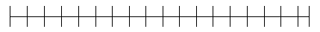

0,44 0,42 0,4 D 0,32 0,28

17.9. Fill in the missing numbers.
1 ; ________ ; _________ ; __________ ; 2 ; 2,25 ; 2,5.

17.10. Fill in the missing numbers on the number line.
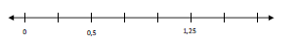

17.11. Place 5,6 and 6,4 in their correct positions on the number line.
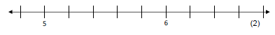

17.12. Complete the number chain.
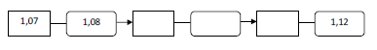

- ADD AND SUBTRACT POSITIVE DECIMAL FRACTIONS
MULTIPLY DECIMAL FRACTIONS BY 10 AND 100.

18.1. Add: 21,67 + 10,93
_______________________________
_______________________________
_______________________________

18.2. Calculate: 31, 67 + 21, 93
______________________
______________________
______________________

  - Circle the letter of the correct answer.
25,27 x 100 = _______________

- 2 527 B. 0,2527 C. 2, 527 D. 257,2

  - Calculate : 3,23 + 5, 62.
__________________________________
18.5 Calculate: 6 – 2,34.
___________________

18.6 Calculate: 2,4 + 4,2 - _______= 0,28

18.7 True or false? 0,34 x 100 = 3,4 x 10 ______________

CONTENT AREA: PATTERNS, FUNCTIONS AND ALGEBRA

- GEOMETRIC AND NUMERIC PATTERNS

Activities:
- Geometric Patterns:
Circle the letter of the correct answer.
1. 1What will the next bead in this necklace look like?
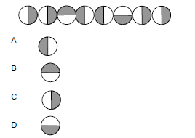

  - Ingrid has stacked some blocks. Use the same pattern to draw the fifth stack.
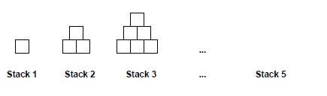

  - Draw the next 5 beads in the string if the beading pattern continues.
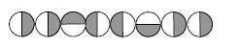
________________________________

  - Answer the questions about the following diagram pattern.
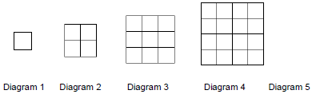

____ ____________

1.4.1Complete the table.
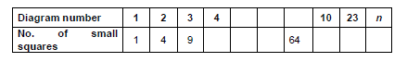

1.4.2 In your own words, describe the rule you used to draw diagram 5.
_______________________________________________________

1.4.3 In your own words, describe how you have found the number of small squares in diagram n. ___________________________________________________

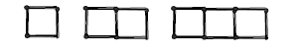
1.4.4

The above 'growing' diagrams are made of matches. Draw the next diagram.

________________________________________

- Number Patterns and Sequence:
Example:
7;11;16;22;29…..

Activities:
  - Complete the following number sequence.

    - 3; 7; 12; 18; _____; _____; _____; _____.

2.1.2 1; 1; 2; 3; 5; _____; _____; _____; _____.

  - Complete the table below.
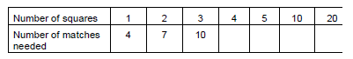

  - Look at the number sequence below and answer the questions.

- ; 2 ; 4 ; 7 ; 11 ; 16 ; 22 ;

2.3.1 Write the next number in the sequence.
_____________________________

    - Write down how to find term 9 in the sequence.

  - At a party Pedro arranges small square tables, next to each other in a straight row, so that
one person sits at each of the available sides of the table. For example with 4 tables, he can seat 10 people, as shown in the sketch below.
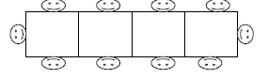

    - If Pedro arranges 5 tables as shown above, how many people can be seated? ___________________________________

    - How many tables must he place next to each other if he wants to seat 20 people? ______________________________________________

    - Explain your answer. _____________________________________________

    - How many tables must he place next to each other if he wants to seat 30 people? ______________________________________________

2.5. What is the seventh number in the following sequence?
5; 10; 15; 20; …__________________

- Number Sentences:
Example:
Δ x 4 + 8 = 28

Activities:
  - Solve the following number sentence:
4 x Δ – 3 = 25 Δ = __________________

  - Fill the correct number in the number sentence: 36 ÷ _______ - 3 = 9.

  - Write a number sentence for the following word problem.
A farm worker gets paid R150 a day for 5 days every week. How much will she earn in 6
weeks?
_________________________________________________________

  - Write a word problem for the following number sentence:
27 x 23 + 15 = 636
______________________________________________________________

  - Write the following as a number sentence:
Our school grounds had twelve trees. On Arbour day we doubled the number. Three trees dried up and we are left with twenty one.
_____________________________________________________________

  - To earn some extra money, Anne makes necklaces to sell to her friends. The one she is
making is made up of 3 sets of red beads and 3 sets of white beads and looks like this:
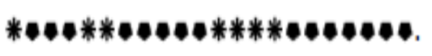
If she continues with this pattern, how many beads of each colour will be in the next set?
_____________________________________________________________
_____________________________________________________________
3.7. Calculate the value of x if x – 41 = 12
________________________________________________________
________________________________________________________

3.8. Draw a circle around the letter of the correct answer.
Which number sentence below has the same meaning as:
5 x (6 + 2)

a. (5 x 6) + 2 b. (5 x 2) + 6 c. (6 + 2) x 5 d. (5 + 2) x 6

3.9. Calculate: 10 000 ÷ 20 – 25 × 20
___________________________________________

3.10. Complete the number sentence 125 x _________ = 123 250

- FLOW DIAGRAMS
Example:

Activities:

4.1 Find the unknown number that completes the flow diagram.
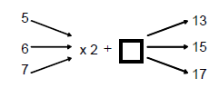

Write your answer in the space provided below.


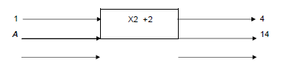
4.2. Determine the value of A and B in the following flow diagram.

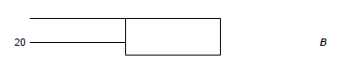

CONTENT AREA:
SPACE AND SHAPE

- 2-D SHAPES AND 3-D OBJECTS:

1.1Similarities and Differences of the Square, Rectangles and Parallelograms
Example:

Square → Rectangle → Parallelogram →

Activities:
Answer the following questions.

What name can you give to a shape with:
1.1.1 Two pairs of opposite sides’ equal and each angle equal to 90⁰.
____________________________________________

1.1.2 Two pairs of opposite sides’ parallel and two pairs of opposite angles equal to 180⁰ .
___________________________________________

1.2. Write down the name of one shape with:
1.2.1 All four sides equal. _________________________________

    - Two pairs of opposite sides equal. ___________________________

1.3 List all the similarities between a square and a rectangle.
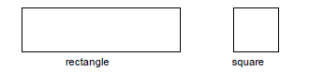

__________________________________
___________________________________
___________________________________
__________________________________
__________________________________

2. Number of Triangles:
2.1. The figure below is made up of triangles of different sizes:
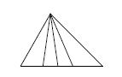

How many triangles are there in this figure? ________________

___________________________________

3.2D Shapes and 3D Objects:

3.1. Write down the name of each figure in the spaces below.
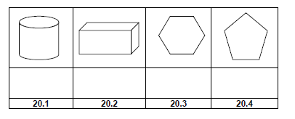

3.2 Draw a circle around the letter of the correct answer.
Look at the picture of the house below.
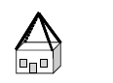
Which shape describes the shape of the roof?

a. rectangular prism
b. pyramid
c. cylinder
d. cone
3.3. Look at the following traffic signs and name each according to the shape of the figure.
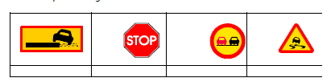

3.4. Draw lines to match the following 3D objects to their names.

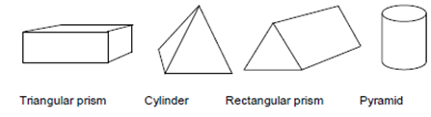

3.5. Complete the following table:
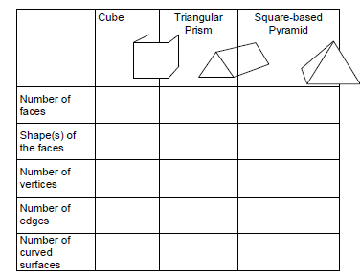

(15 ÷ 3)

3.6. Complete the following table:
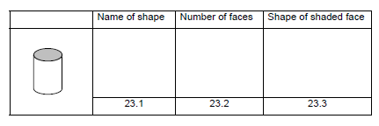

3.7. This is a drawing of a box of chocolates.

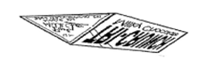

11.1 What kind of 3-D object is it? ___________________________
  - How many triangular faces does the box have? ___________________

- Angles:

4.1. Draw a circle around the letter of the correct answer.
In the diagram Ŝ = 120°. Ô = 180°.
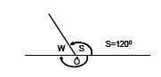

What is the measurement of angle W?
a. 180⁰ −120⁰
b. 360⁰ −120⁰
c. 120⁰ + 90⁰
d. 360⁰ +120⁰

4.2. This is a picture of the famous Leaning Tower of Pisa. At the base of the Tower mark with
a cross (x) an angle greater than 90⁰ and with a dot an angle less than 90⁰.
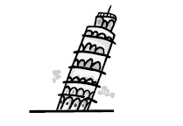

- USE THE PROPERTIES OF ROTATIONS, REFLECTIONS AND TRANSLATIONS
TO DESCRIBE TRANSFORMATIONS OF 2-D SHAPES AND 3-D OBJECTS.
TRANSFORMATIONS

5.1. Draw the next figure that follows in the space provided:
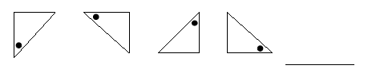

5.2. What kind of transformation(s) is illustrated in each of the following?
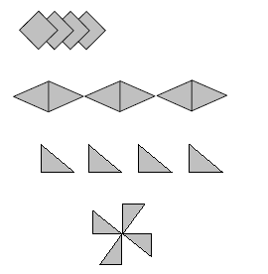

5.2.1 __________________

5.2.2 ___________________

5.2.3 ___________________

5.2.4 _____________________

5.3. Reflect the given shape in the horizontal dotted line.
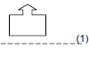

5.4. Will the following picture be completed if you reflect or translate it?

____________________

- RECOGNISE, DRAW AND DESCRIBE LINE(S) OF SYMMETRY IN 2-D SHAPES.


6.1. How many lines of symmetry can be drawn in these pictures?

______________ ____________

6.2. Draw the line(s) of symmetry on the 2 shapes below.


6.3. Which of the squares can be rotated to fit exactly onto the adjacent square?
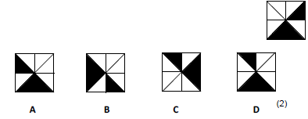

6.4. Only half of the picture has been drawn. Draw the rest of the picture.


- POSITIONS and VIEWS

7. Here is a cube building. Next to it is a view from the right.
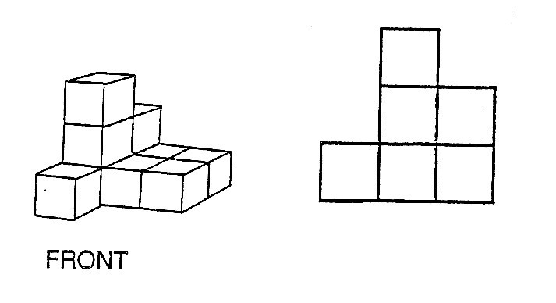
7.1 Which of these views from the front belong to the building 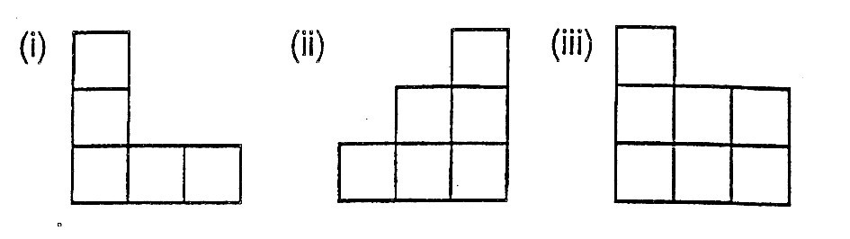
7.2 Which of these views from the back belong to the building?
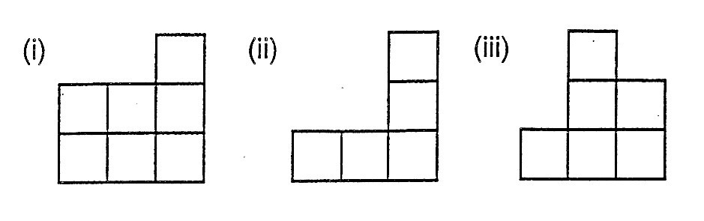
7.3 From which position was this photo taken?
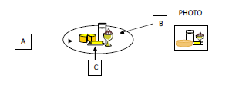

__________________

  - If the figure below is folded to form a cube, which letter will be opposite T?
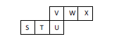

__________________________

  - Circle the diagram on the right which shows the top view of Kim's block tower on the left?
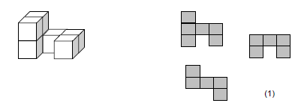

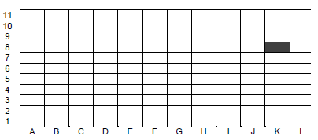
  - The 'Pretty Tilings’ company specialises in decorative tiling of floors. They also fix or replace damaged tiles on floors. The inspector gave the repairman a written description of the 2 tiles that need to be replaced.

7.6.1. Shade the tiles in position B3 and 7H on the sketch of the floor.
7.6.2. Which tile is marked on the sketch? ________________

CONTENT AREA: MEASUREMENT

MASS, CAPACITY, LENGTH AND TEMPERATURE:

1.1 MASS
Look at the scale and answer the questions below.
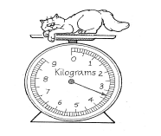

    - How many grams are shown by each small division of the scale? ______________

    - What is the mass of the kitten in grams? ___________________

    - Write the kitten's mass in kilogram. _________________________

    - By how much is the kitten's mass less than 9kg? ____________________

  - Anthea packs a suitcase. There are 8 parcels in the suitcase, each with a mass of 600 g. The
empty suitcase weighs 400 g.
What is the total mass of the packed suitcase in kilograms?
_________________________________
_________________________________

  - Match the load to the most appropriate object by drawing lines.
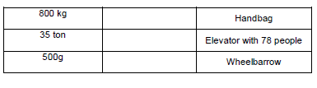

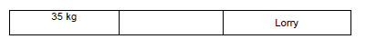

  - Convert these measurements to grams:
- 3 kg = _________ g
- 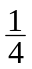kg = _________ g
- 2 kg 425 g = ________kg

  - Complete.

a) 3 tons = ________ kg

b) 1 kg 25 g = _________ kg

- LENGTH:

2.1. Complete:

2 m 88 cm = ___________________m

2.2. Convert to the required measurement.
2.2.1. 1 m 84 cm as cm ___________________

  - 2. 3,569 m to mm ___________________
2.2.3. 345 m to km ____________________
2.3 Which of the following would you use to measure the perimeter of your classroom?
Write down the correct letter of the instrument
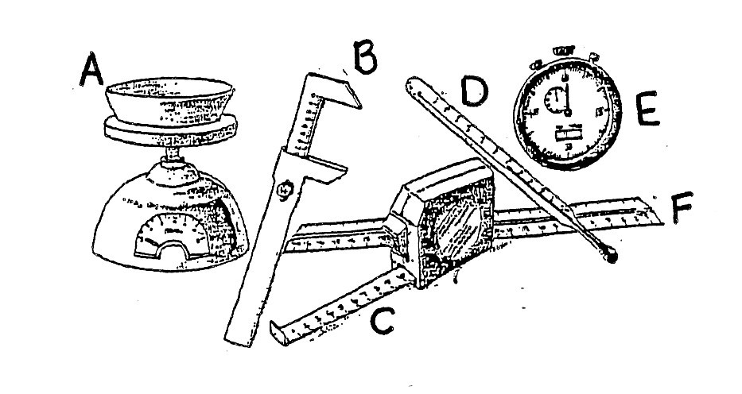___________
2.4
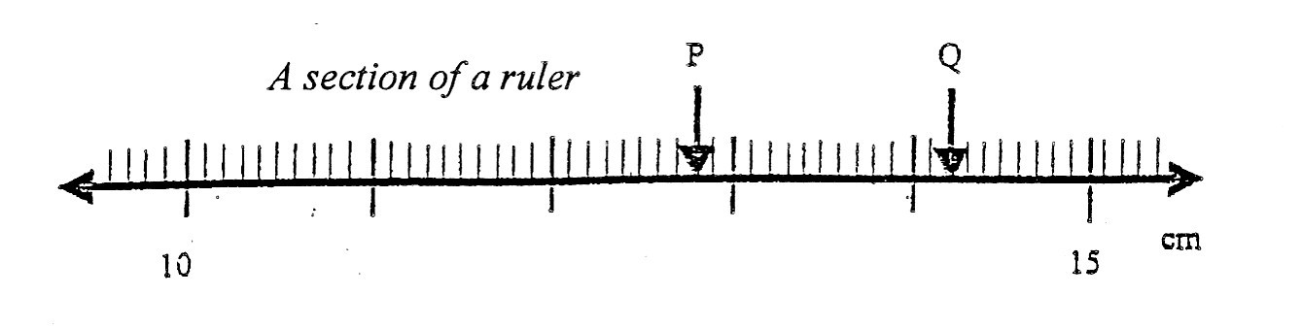____________
a) What does each small division represent?
- What does each large division represent?
__________________________
- What fraction of a cm is each small division?
__________________________
- What is the distance between P and Q?

_______________________________

2.5. Study the picture below and answer questions that follow:
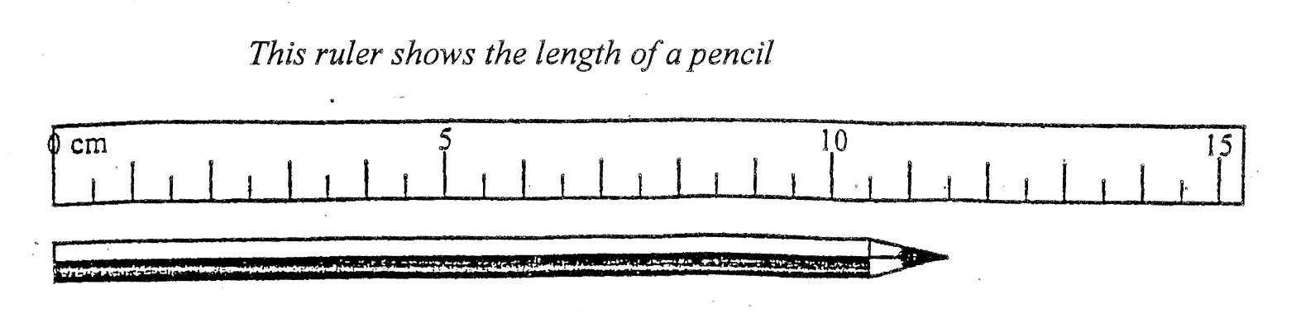
a) What is the length of the pencil?
______________________
b) How many mm in 0,5 cm?
_______________________
c) How many cm in 0,25 m?
________________________

2.6What is the length of this pencil in cm?
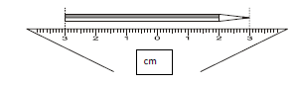

__________________

  - Use the dimensions of the rectangle to answer the questions.
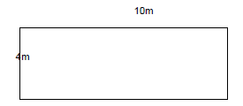

4m

    - What is the ratio of the width to the length? _____________________

    - What is the ratio of the length to the width? ____________________

    - How many times is the rectangle longer than it is wide? ______________

    - What fraction is the width of the length? _________________
  - On the grid below, each block is 1cm by 1cm. ABCD is a rectangle.
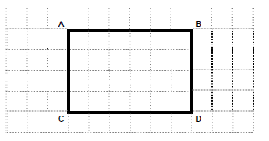

    - What is the length of side AB? ___________________ cm
    - What is the length of side AC? ___________________ cm
    - Write the area of ABCD. ___________________ blocks

  - On the grid below, each block represents 1 cm by 1 cm. ABCD is a rectangle.
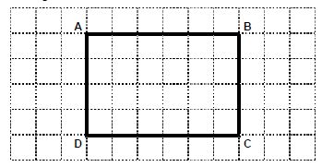

    - The length of side AB = ___________________ cm
2.9.2 The length of side AD = ___________________ cm
    - How many square centimetres are in ABCD? ___________ cm²

  - Draw a circle around the letter of the correct answer.
Jason lives in a house 3 kilometres from the nearest shopping centre.
His school is a further 350 m from the shopping centre.
How far is Jason’s house from the school in metres?
a. 353 b. 347 c. 3 350 d. 2 350
3. CAPACITY:
3.1. One cup holds 250 ml of milk.
Fill in the missing numbers to answer the question, how many cups of milk can I get from:
a) 4 litres = _______ cups
b) 1, 5 litres = ______ cups
3.2. Convert these –
- 5 = ________m
- 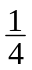 = ________m
- 3,750 = ________m

3.3. Study the pictures below and answer questions that follow:
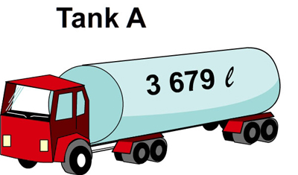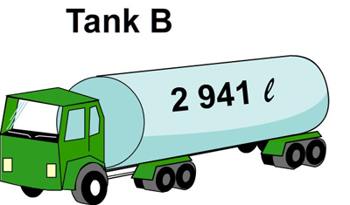
- How much fuel is there in tank A and B together?
___________________________
- How much more fuel is there in Tank A than tank B?
____________________________
- Both tanks hold the same amount of fuel, that is 4 000ℓ each.
How much must be added to tank A to fill it?
__________________________
- Both tanks hold the same amount of fuel, that is 4 000ℓ each.
How much must be added to tank B to fill it?
________________________________

3.4. Draw a circle around the letter of the correct answer.
A glass has a volume of 250 ml. How many glasses can we fill from a 2-litre bottle of cool
drink?

a. 4 glasses b. 8 glasses c. 10 glasses d. 2 glasses

3.5. Ingrid mixes orange juice and water in the ratio 1:8. The mixture has 200 ml of orange juice.
What is the total amount of mixture? Circle the correct answer:
18 litres; 1 800 ml; 2 litres; 1 600ml

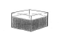
3.6. This tank holds 12 litres when full.
How much water is there in the tank when it is ¾ full?
__________________________________
3.7. 250 ml of energy concentrate makes 1 litre of energy drink.
How much concentrate do I need to make 1,5 litres of energy drink?
__________________________________________________________
How much concentrate do I need to make 5 litres of energy drink?
_______________________________________________

3.8. If you invite 45 friends to your party, and each friend is allowed 2 cups of cooldrink, how
many 2- litre bottles of cooldrink should you buy?
________________________________________________

3.9. Underline the correct answer. How much water will a kitchen kettle hold?
a) 1.7 litres b) 20 litres c) 2 litres d) 500 ml

4. TEMPERATURE:
4.1. Complete:
A B
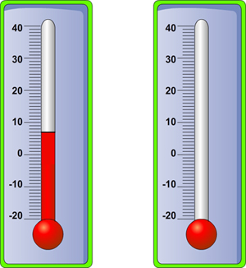
a) What does thermometer A read? ______
b) What is 20ºC warmer than - 10ºC? ______
c) Fill in on thermometer B 37ºC (Healthy body temperature) _________
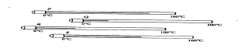

4.2.

Which of the above thermometers shows a temperature of?
- about 60⁰ C ? __________________

- about 30⁰ C? ___________________
4.3. On a winter morning, the reading on the thermometer was -10 C at 6 o’clock. At 2 o’clock, the
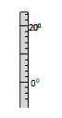
same afternoon the temperature rises to 180 C.

Write down how many degrees the temperature increased during the day. ____________
- TIME

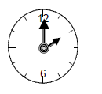
5.1. Use the watch below to answer the question.

Write the time shown on the clock as a 24-hour clock time. ____________________

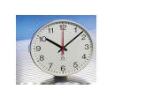
5.2. Write down the time indicated on the face of the clock in words and in digital time.

___________________________________

____________________________________

5.3. Draw the hands of the watch to show the time as 19:20.
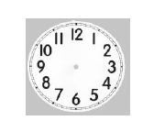

5.4. Write down the time shown on the cellphone in words.
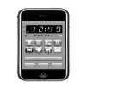

_____________________________________

5.5. Complete the table.
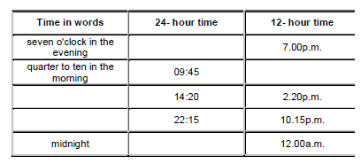

  - The soccer practice started at 3 ‘o clock and ended at 15:30. How long did the players practise? _________________________________________

  - A soccer match started at 16:00 and ended at 17:40. How long did the match last?
_______________________________________

  - What time did the TV program stop if it started at 6 ‘o clock and the duration was 1,5 hours?
_______________________________________

  - Your school starts at 08:00 in the morning and ends at 13:30. How much time are you spending at school per day?
________________________________________________

  - Use this Bus Timetable to answer the questions that follow.
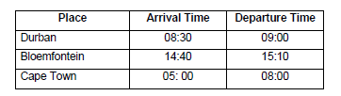

5.10.1. How many hours and minutes does it take the bus to travel from Durban to Bloemfontein?
______________________________________________________

Circle the letter of the correct answer.
5.10.2. How many hours does it take the bus to travel from Durban to Cape Town?

a. 9 b. 20 c. 14 d. 17
5.11 Convert the following as indicated.
- 5 minutes = _______ seconds

- 17 hours = _______ minutes

- 4 hours = _______ seconds

- 1 week = _______ minutes

e. 2150 years = _______ decades
5.12. A man leaves Cape Town at 10.30 p.m. and arrives in London at
6.45 a.m. the next day. How long did his flight take?
___________________________________________________

5.13. If you watch TV for 45 minutes every day, how much time will you spend watching TV in 6
weeks? ______________________________________
______________________________________

CONTENT AREA: DATA HANDLING
- Tallies

1. 1. Complete the table.
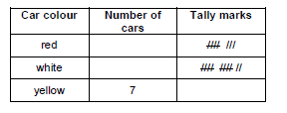

  - The following tally chart shows the number of lions and giraffes which learners saw in the zoo.

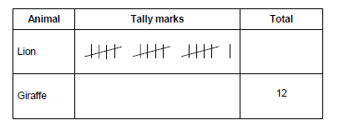

Complete your answers in the table above.
- 2.1. How many lions did the learners see? _________________ (1)
- 2.2. Fill in the correct number of tally marks for the number of giraffes seen. (1)
1.3. The following is a tally chart of types of sweets sold in a Tuck Shop.
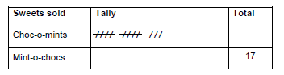

Complete the chart by answering the following questions.
1.3.1. What is the total number of Choc-o-mints sold? ________ (1)
1.3.2. Fill in the correct tally for the Mint-o-chocs sold. (1)

- Bar graphs

2.1 Draw a bar graph to represent the data about the kind of vehicle which 40 customers drive.
Complete the table and use the information to draw a bar graph.

Motor cycle | Car | Minibus | Bakkie | Heavy vehicle
8 | 12 | 8 | 7 | 5

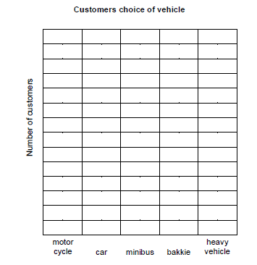

2.2. In a survey, 50 people were asked about the number of people in each of their families. Here
are the numbers they gave.
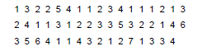

Organise the data in a frequency table.

(10)

2.3. Learners were asked which of three different TV programmes was their favourite. The results
were recorded in the table below.
Draw a neat, properly labelled bar graph on the grid provided to show this information:
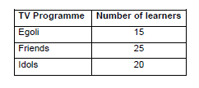

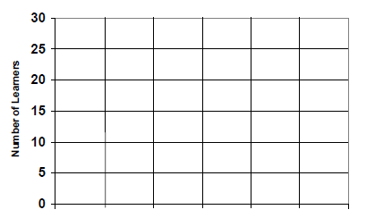

(7)

- Mode, Mean and Median

3.1. The following are the shoe sizes of some Grade 6 learners.
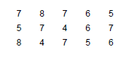

3.1. 1. What is the mode of the shoe sizes? ______________

3.2. 2. What is the median of the shoe sizes? _______________

  - The following is a set of scores obtained by the grade 6 Green class in a mathematics test. The total score of the test is 20.
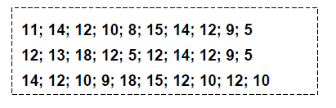

    - How many learners scored 10 in the test? ____________________

    - Which is the most common score obtained by learners? _______________

  - Felicity wrote six maths tests. Her marks, out of 50, were 17, 23, 27, 29, 30 and 36.
Find her mean mark.______________________________
______________________________

3.4. Here are the first round scores in a golf tournament: 73, 79, 78, 80, 79, 74, 72, 76, 79, 77 and
72.
What is the median score?___________________________________
__________________________________
3.5. The price of a loaf of bread at ten shops was found to be:

R4,40 R4,90 R5,10 R6,80 R6,20
R4,40 R6,90 R5,10 R4,40 R4,70.

What is the mode of the prices? __________________________

- Interpreting graphs

4.1. This graph shows the amount of cool drink sold by a café owner in a week.
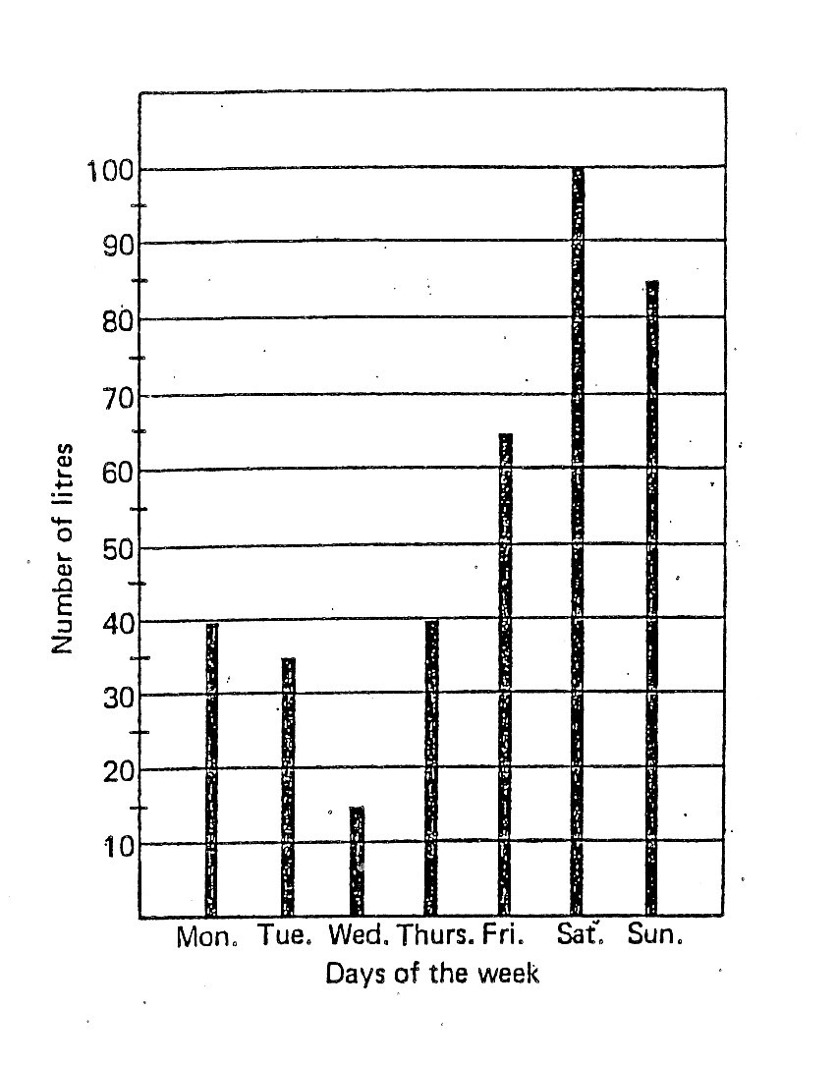
4.1.1. What kind of graph is this? __________________________
4.1.2 . What does the horizontal axis show? __________________________
4.1.3. On which day did he sell the least amount?__________________________
4.1.4. How many litres did he sell on Saturday? __________________________
4.1.5. Why do you think he sold so much on Saturday?
________________________________
4.1.6. On which two days did he sell equal amounts of cool drink?
____________________________
4.1.7 How much did he sell on Tuesday? ____________________________
4.1.8. How many more litres did he sell on Saturday than on Sunday?
____________________________
5. Residents in a town were interviewed on their water usage per day. The following graph was
obtained from the data.
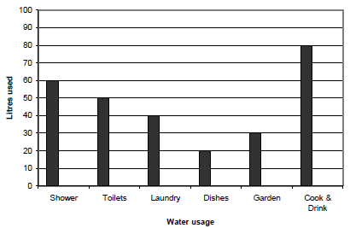

Use the information in the graph to answer the following questions.

5.1. How many litres of water do households use to shower? ______________

5.2. What activity used the least amount of water? ________________________

6. The following graph represents water usage of one household per week.
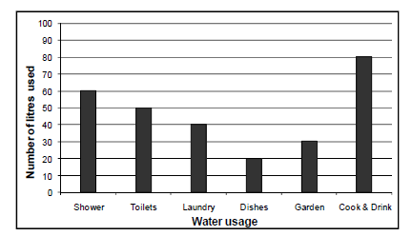
Use the information in the graph to answer the following questions.

6.1. How many litres of water does the household use to Shower and Garden?
_____________________________________________________

6.2. What is the difference between this household’s water usage of Dishes and Cook &
Drink?_____________________________________________________

7. 120 learners in Grade 6 were asked how they came to school, and a pie graph was drawn to
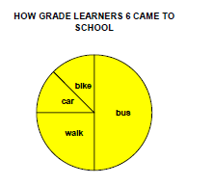
illustrate the results.

  - What fraction of the learners walked to school? ________________
7.2 How many learners came to school by bike? _____________________

